

|  |  |  |
| --- | --- | --- |
| **Module Code** | **:** | **AAPP009-4-2-WDT**– Web Development |
| **Intake Code** | **:** | UCDF2009ICT(SE) |
| **Lecturer Name** | **:** | Mohamad Firdaus Bin Che Abdul Rani |
| **Hand in Date** | **:** | 07/02/2022 |
| **Due Date** | **:** | 24/04/2022 |
| **Group Leader** | **:** | Chai Yao Yang |

|  |  |
| --- | --- |
| **Student ID** | **Student Name** |
| TP060683 | Chai Yao Yang |
| TP061946 | Chua Jing Cheng |
| TP061440 | Jason Wong Chuin Hao |
| TP061955 | Andy Mah Jun Wei |

Table of Contents

Gantt Chart (Project Plan) 3

Introduction 5

Justifications of Style Design Choice and Targeted Audience 6

System Design 7

Wireframes 7

Navigational Structure 29

Activity Diagram / Flowchart 30

Entity Relational Diagrams (ERD) 46

Implementation 47

Create 47

Read 50

Update 52

Delete 54

Login 56

Signup 58

Self-created CSS and JavaScript 62

Main Section (User Guidance and Sample Screen) 67

General Functionalities 67

User Functionalities 80

Admin Functionalities 85

# Gantt Chart (Project Plan)

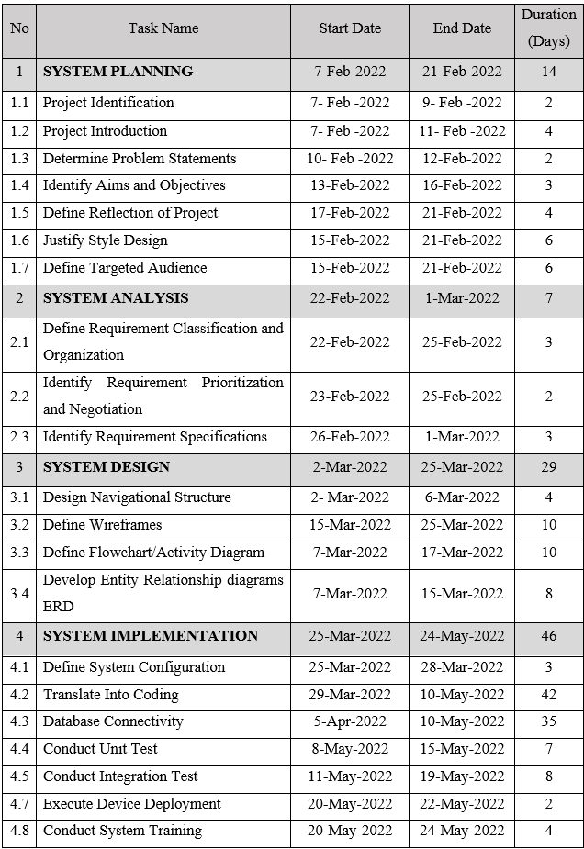

*Figure 1: Gantt Chart*

# Introduction

**Project Background**

The economic corruption happening in our country affects the business operations of small and medium-sized enterprises as well as the quality of lifestyle of the citizens, especially those poor and homeless. A non-profit organization named The Elderly Home’s Club offers physical support and medical services emphasize to the homeless seniors' citizens. We provide places to settle down themselves and enjoy a better quality of life under the shelter of the organization. A project is recommended to produce a web-based system to assist the community in reaching us. Mainly, the project allows senior citizens to make online medical care appointments to enjoy health care services provided without any charges. Overall, the project is designed to increase the reputation of the organization and allow us to spread love and caring to the community.

**Problem statement**

There are several departments such as the shelter department and medical care department that are ready to serve, but it is difficult for the seniors to reach the services provided. The information about the organization is limited to exposure in the community. Considering the advanced technologies and complex procedures of connecting us to the public are somehow unfamiliar to the senior citizen, an effective solution is required to contribute and simplify the operations of the online medical care appointment system as well as to attain the aims and objectives of the organization.

**Objectives**

- To develop a web-based system for making online medical care appointments purpose.

- To spread medical health awareness and support medical services in the community.

- To build up the engagement and interaction with the community effectively and efficiently.

- To ensure the growth of the organization's structure and services provided.

**Reflection**

The website serves the primary purpose of allowing the public to make medical care appointments without hassle and hustle. The public can be based on the availability of medical care services provided such as pharmaceutical care, nutritional support, and administering medication to make an online appointment in advance then seek physical face-to-face medical consultation. It allows the user to view the schedule and select the specific doctor for making an appointment.

The main page of the website will display the general information of The Elderly Home’s Club including our location and achievement. It will explain the services and support that are carried out by the organizations. The public and our staff are allowed to share their experiences and knowledge as feedback towards medical care which will increase medical health awareness in their lifestyle.

Overall, the website is expected to contribute into simplified the communication and connection between the public and the organization and allowing more interaction with the community. Eventually, it ensures the growth of the organization and adds more medical care services to senior citizens.

# Justifications of Style Design Choice and Targeted Audience

In line with our objectives, we had to design a website that would be available to the elderly. Therefore, based on the fact that elders may face different questions while approaching our webpage, we have designed a website that can be easily used by elders. For instance, on our website, our font size will be adjusted to a minimum 12-points font so that elders can see it clearly and easily. Meanwhile, important words such as appointments or schedules are bolded for clarity to the elders. Not only that, but our website is not overly complicated in terms of typography, making it easy for seniors to choose according to their needs. In addition, colour is one of the most important factors influencing first impressions and the feeling of continuing to use the site. Therefore, we need to use the appropriate colours for the overall primary colour palette depending on the situation. For example, we have used green and blue to design our website. Green symbolizes health, tranquillity, and serenity. Also, our website is a medical appointment website, so we needed to project an image of trustworthiness and reliability. Blue is exactly the colour associated with reliability.

Great design begins with an understanding of the people for whom it is designed. In line with this, our main focus is on the homeless and elderly in poverty. Nowadays, some elderly people are not familiar with the online system. Not only that, but those elderly who are homeless and poor, they cannot afford to go to the doctor. Therefore, they are exactly who we have designed this website to use, and the online medical appointment system will provide a convenient platform or access for the elderly to have a way to see a doctor.

# System Design

## Wireframes

**Customer interface**

**Header**

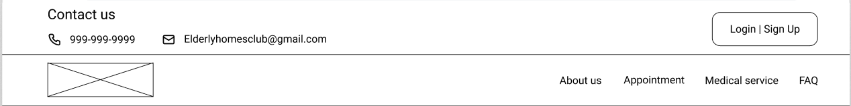

*Figure 2.1.1: Header*

The header on top contains EHC contact details and a login link to the login page. The login link should change to the user’s name after logging in. Below consist of the EHC logo and a navigation bar. The EHC logo should be clickable and direct the user to the homepage.

**Footer**

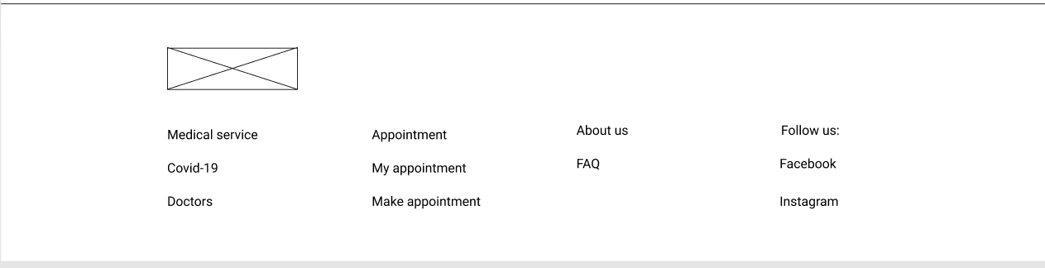

*Figure 2.1.2: Footer*

The footer’s crossed box is the EHC logo. Below it is links that link to the corresponding page.

**Homepage**

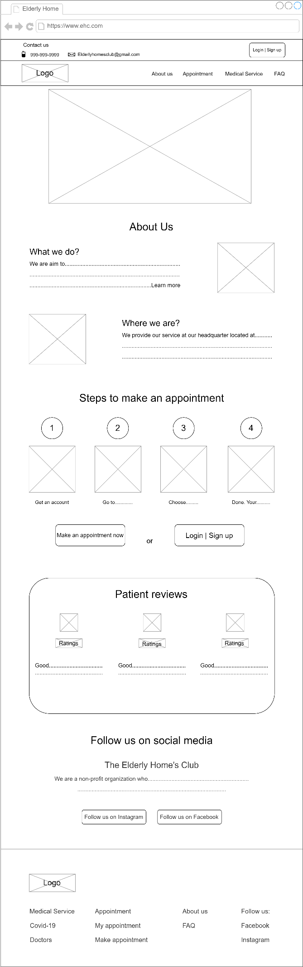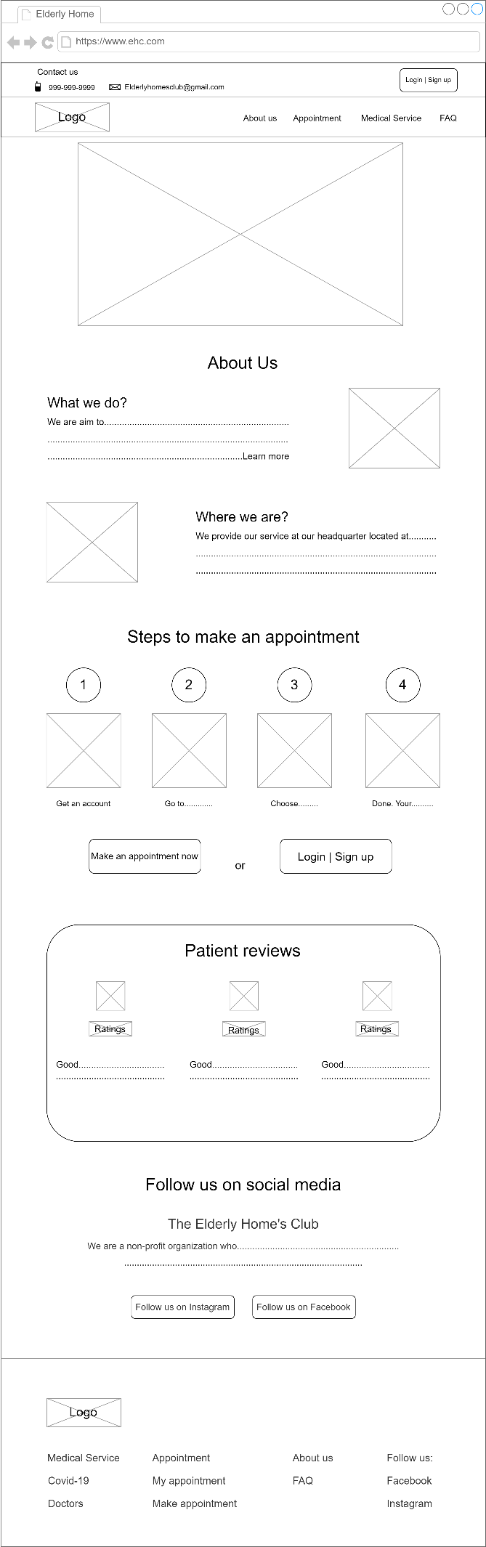

*Figure 2.1.3: Homepage*

The first big and crossed box is a banner. The crossed box in the about us section is the EHC logo and a map with a location pin. In the steps section, it should contain instructional pictures. Below it, the login and sign-up button should disappear after the user logs in, and the remaining button should be centered. The review section should contain customers’ portraits, and the rating should have star icons and fractions.

**Login/sign up**

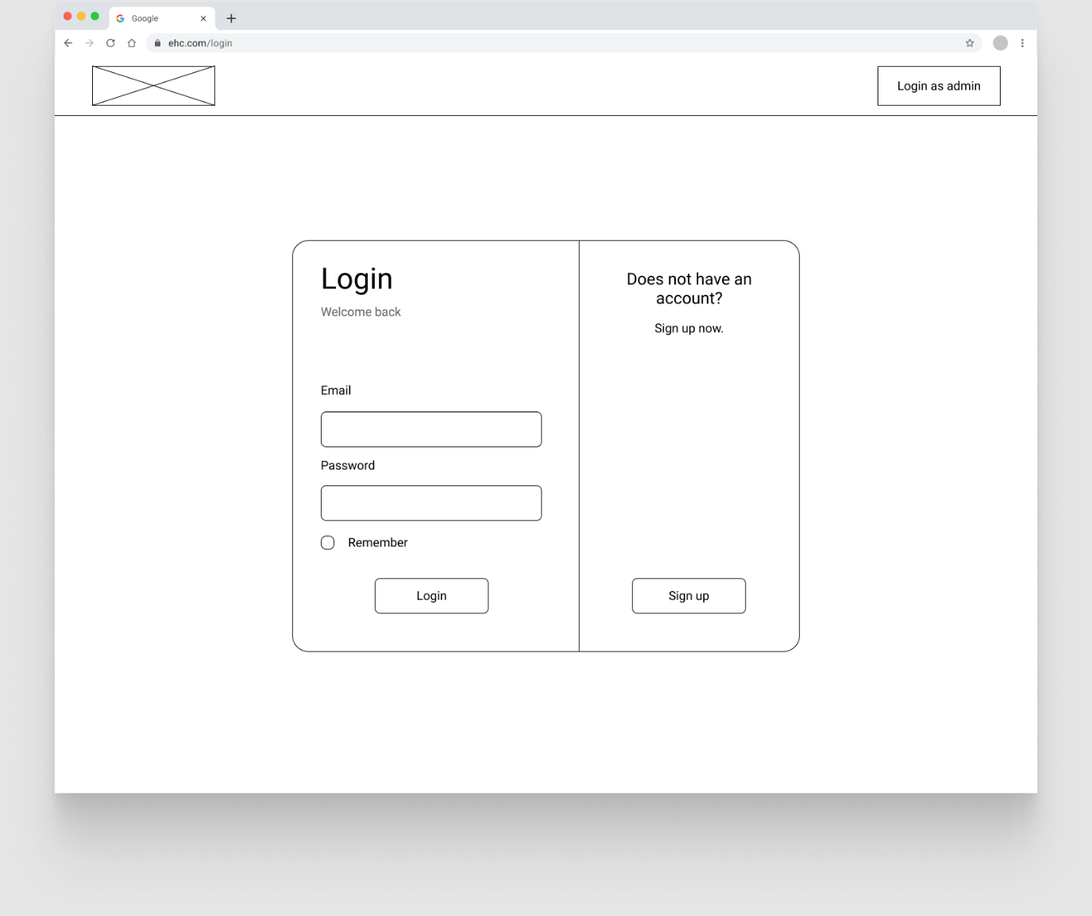

*Figure 2.1.4: User Login/Signup*

The crossed box on the top left is the EHC logo. The button on the right is a link to the admin login page. The email should be text type, and the password box input should be protected. Below is a checkbox for the remember usage.

**Sign up**

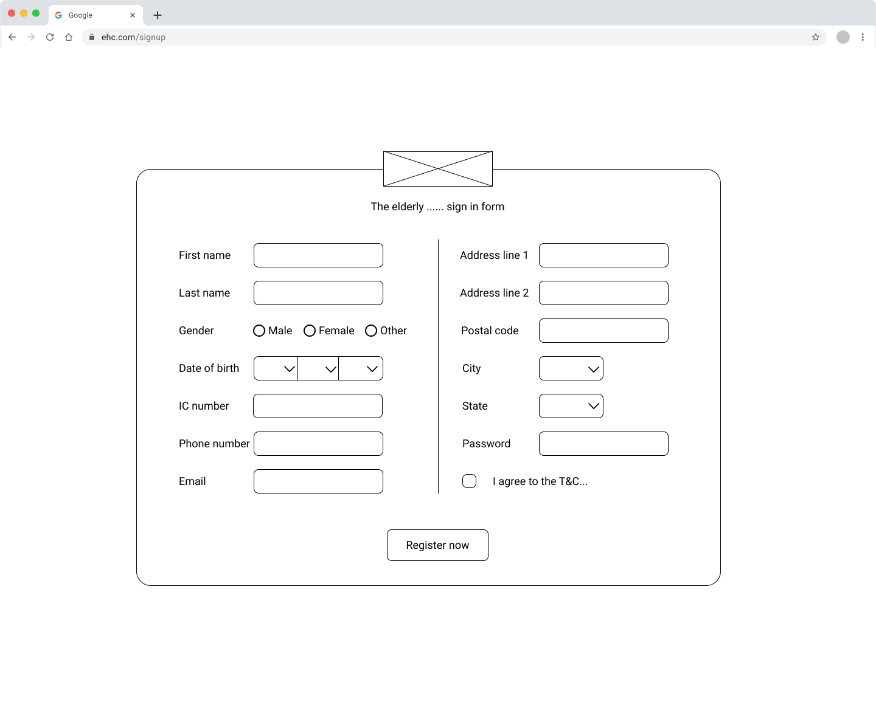

*Figure 2.1.5: User Signup*

This page should provide the user text input fields, and the gender field should use HTML radio type.

**Login (Admin)**

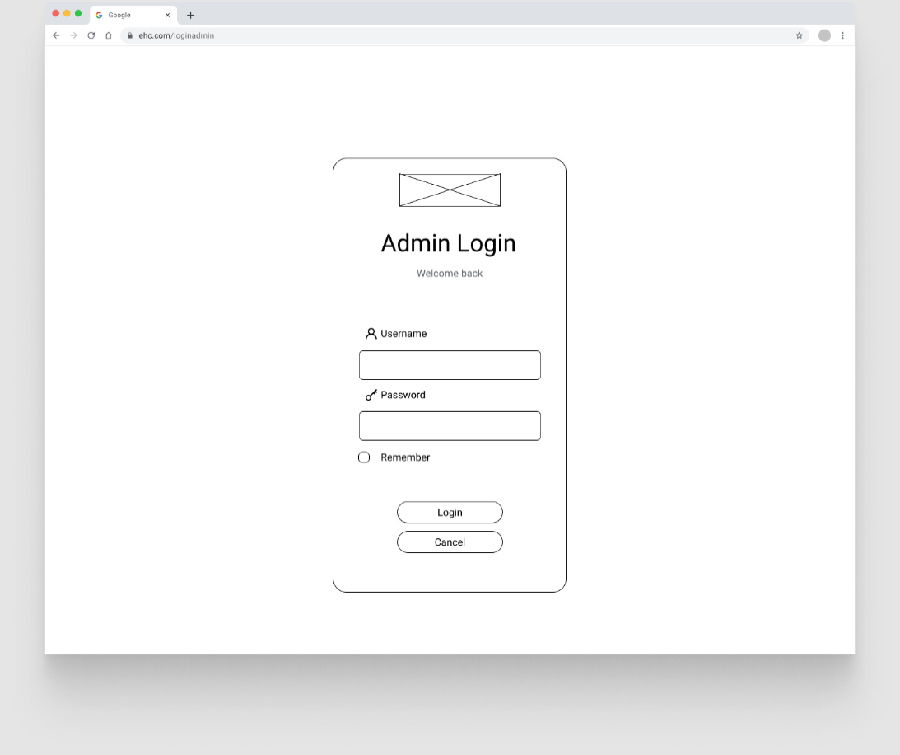

*Figure 2.1.6: Admin login*

This page consists of two text input fields, and the password field input should be protected.

**Appointment**

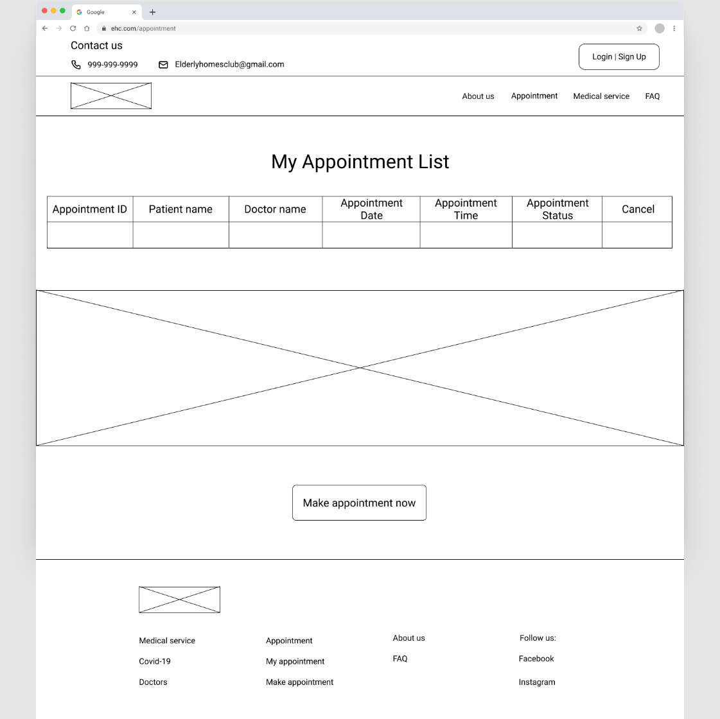

*Figure 2.1.7: My Appointment List*

This page should use a table to display the appointment data, and it should be able to expand when there are many rows of data but do not overlap below elements. The giant cross box in the middle is a banner.

**Make appointment**

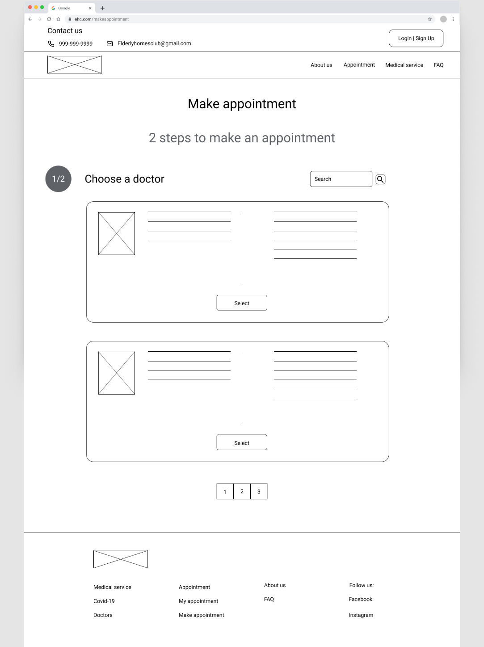

*Figure 2.1.8: Make Appointment*

This page should contain a search box. Beside it is a submit button. The boxes below are doctor information, and the cross box is a doctor’s picture. Above the footer should have a pagination function.

**Choose date & time**

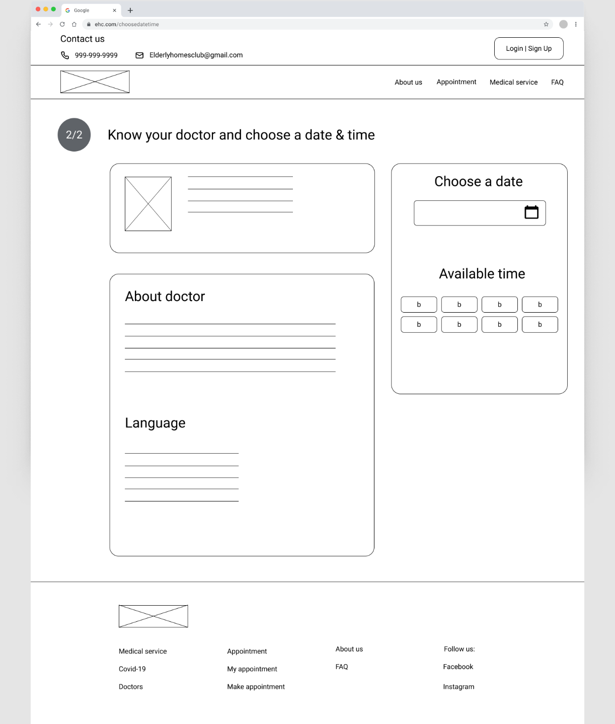

*Figure 2.1.9: Make Appointment with Choose Date and Time*

Two boxes on the left side display doctor information, and the cross box is the doctor’s picture. The left side should provide a date input field, and below it is the time slot buttons.

**Confirm appointment**

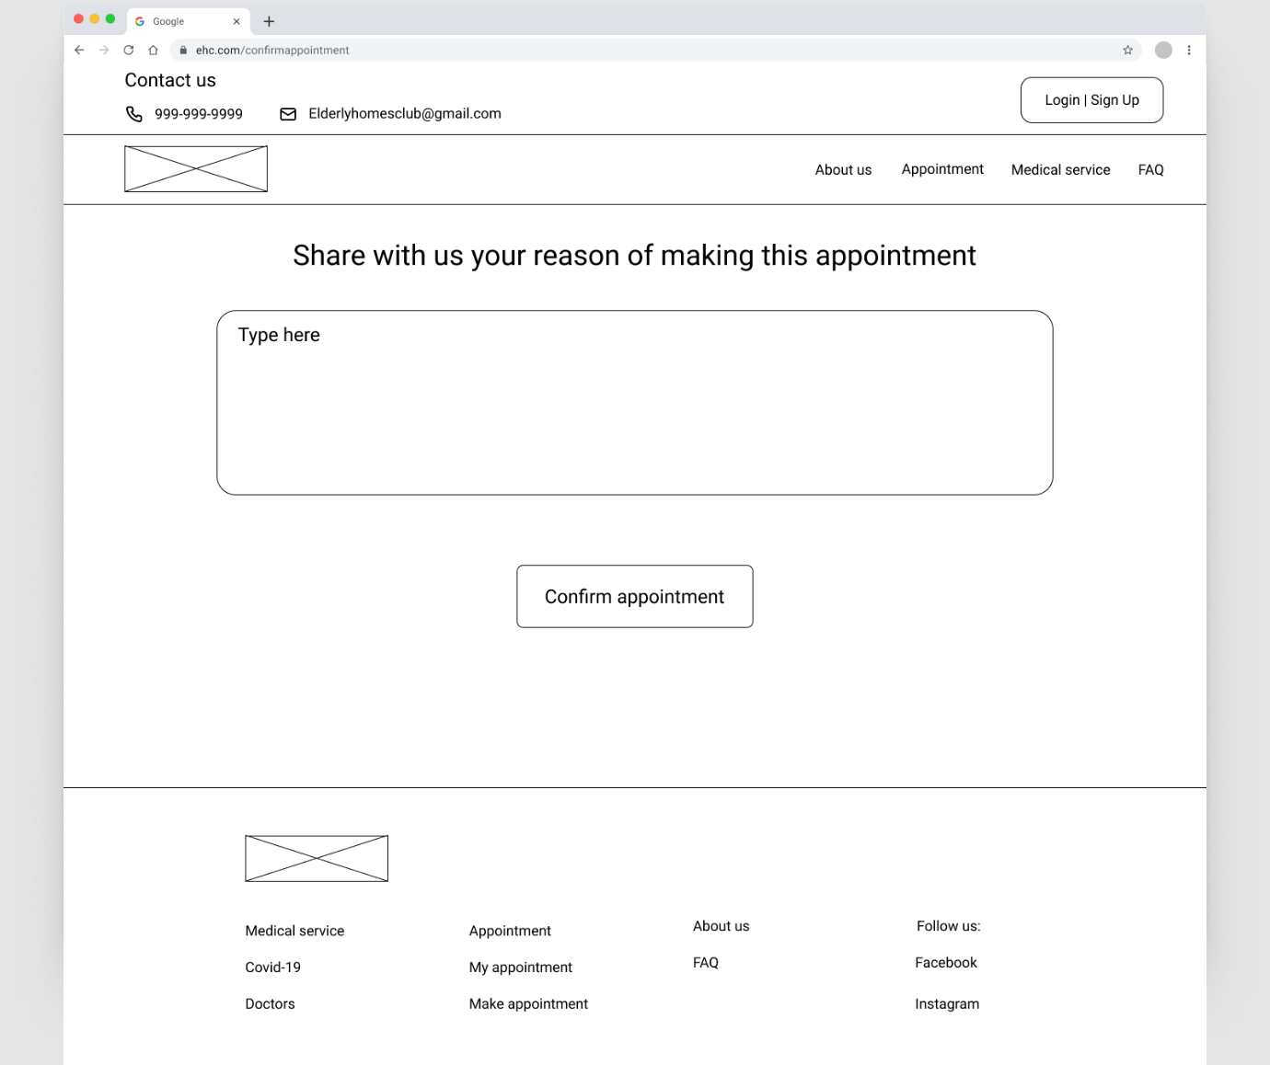

*Figure 2.1.10: Confirm Appointment*

This page should provide a big text area to receive input.

**Covid 19**

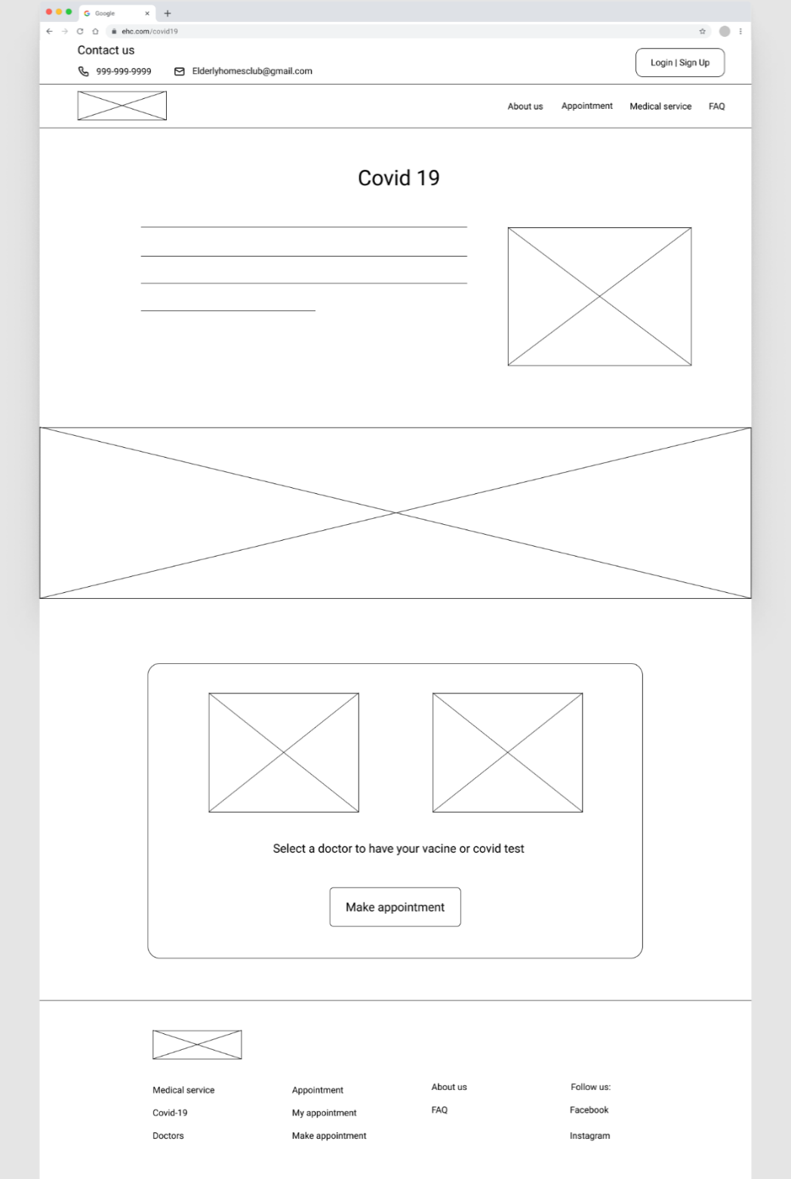

*Figure 2.1.11: Covid 19 Service*

Below the title is a covid-19 introduction, and the cross box beside it is a covid-19 picture. Below is a wide banner. Two cross boxes at the bottom, one is a test picture, and another is a vaccine picture.

**Doctors**

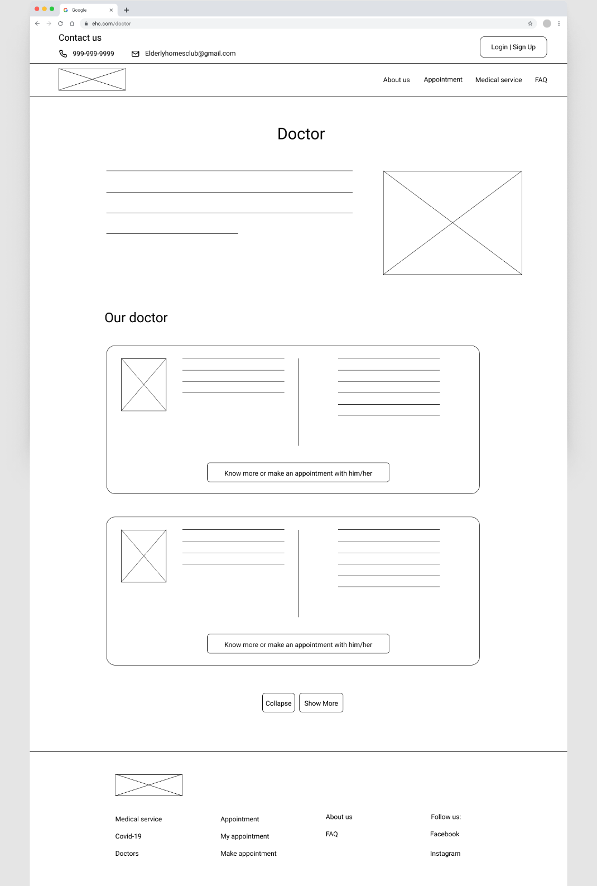

*Figure 2.1.12: Doctor Information*

The first top cross box is a doctor’s picture. The below section is doctor information, and the cross box is the doctor’s picture.

**About us**

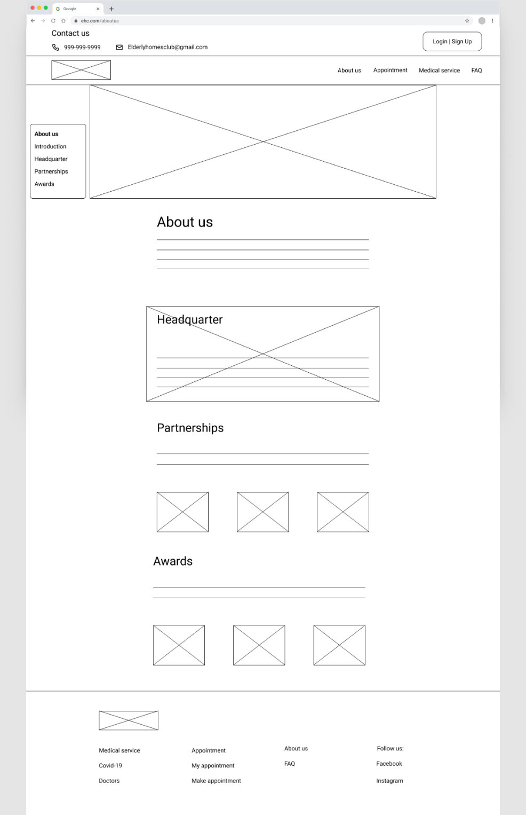

*Figure 2.1.13: Detailed About Us*

The giant cross box on top is a banner. In the headquarter section, there should be a background image behind it. The cross box in the partnership section is the EHC partner’s logo. The award section displays the certification EHC awarded.

**FAQs**

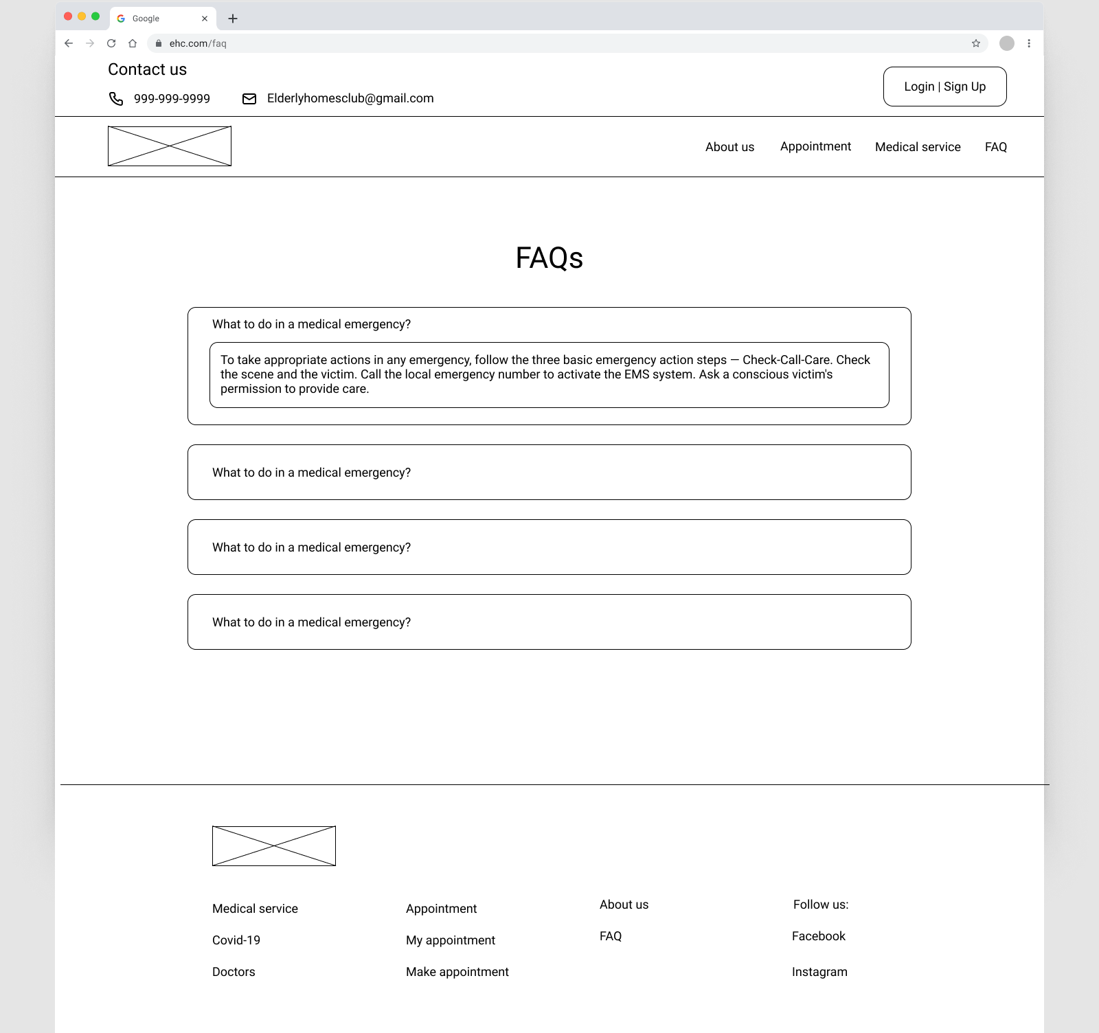

*Figure 2.1.14: FAQ*

The FAQ question box should be able to hide the content and show it when the user clicks the corresponding box.

**User profile**

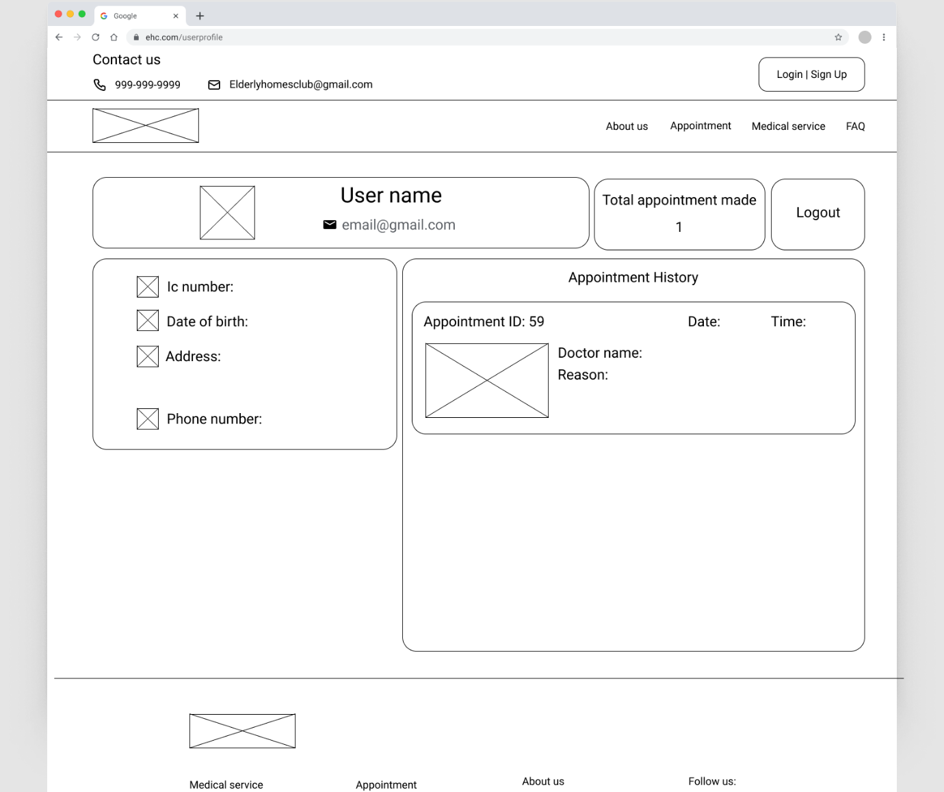

*Figure 2.1.15: User Profile*

The cross box beside the username is a female or male icon depending on the user. Below it, the cross box beside the user information should have a related icon. Cross box in the appointment history is the doctor’s picture. The appointment history section might contain many boxes and should be able to expand without overlapping the footer.

**Admin interface**

**Admin header**

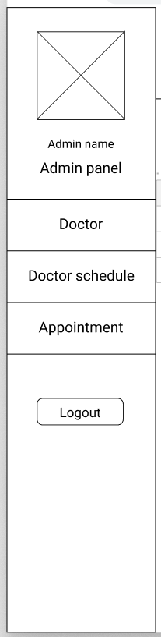

*Figure 2.2.1: Admin Header*

The admin header contains a profile icon, links to each main function page, and a logout button.

**Doctor list**

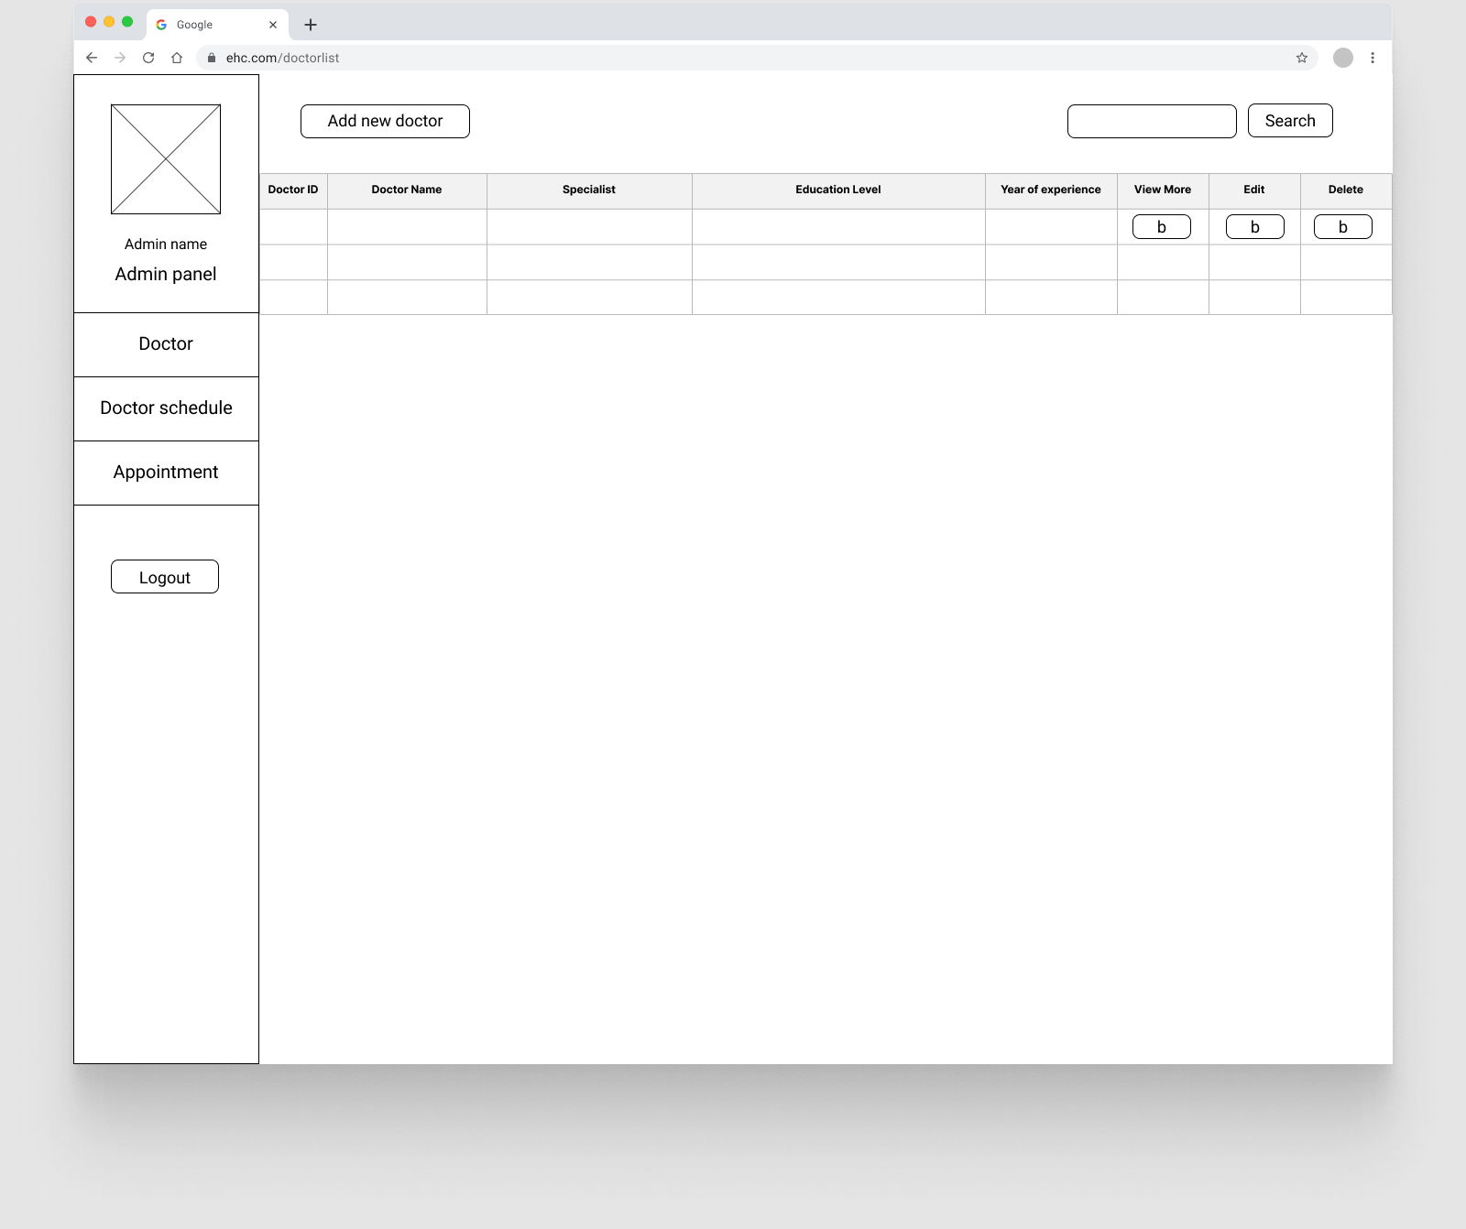

*Figure 2.2.2: Doctor List*

The top of this page contains a link to the add new doctor form page and a search box, and a submit button beside it. Below it should have a table to display the doctor data, and it should be able to expand. In the row of the table, it should contain three buttons for view more, edit and delete.

**Add doctor**

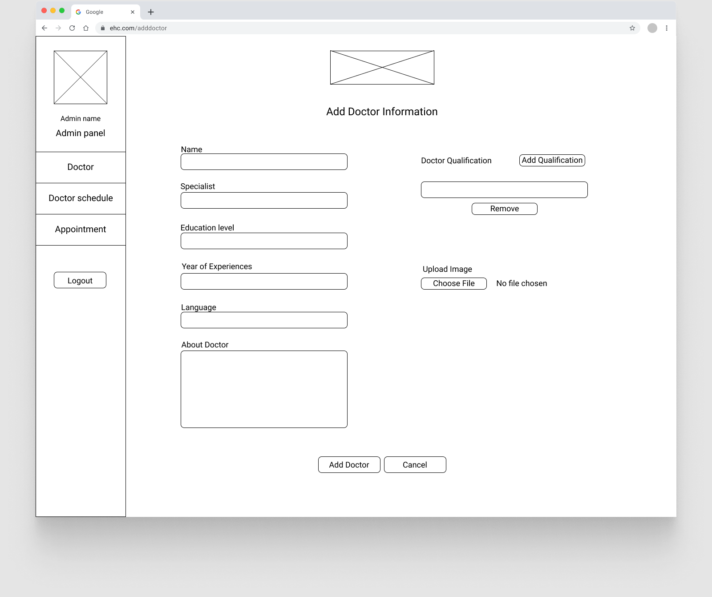

*Figure 2.2.3: Add Doctor*

The right of this page should have several text inputs fields, the language field should be able to select multiple options, and the about doctor field should let the user input multiple lines of text. The doctor qualification section should provide a button that can add an input field whenever it is clicked, and a remove button should be provided. Below it should have a button where the user can choose the file when they click it.

**Edit doctor**

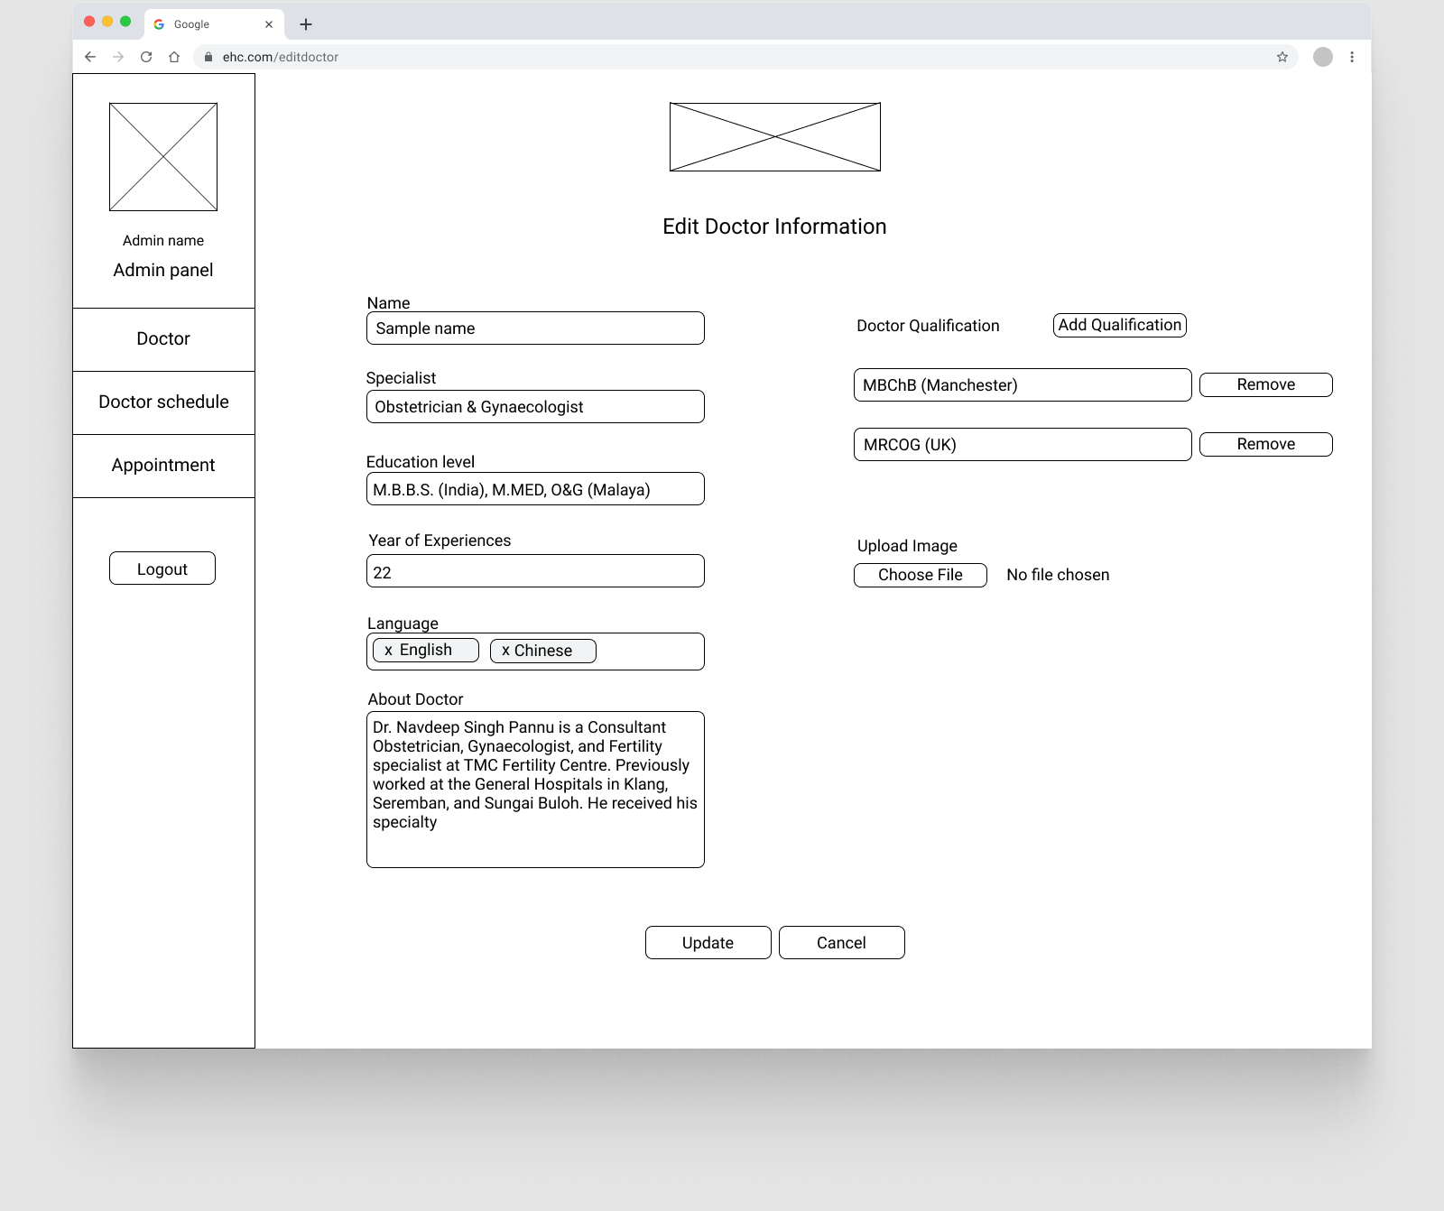

*Figure 2.2.4: Edit Doctor Information*

The layout of this page is the same as the add doctor page. However, this page should be able to retrieve and display old data. The language column should auto select the recorded language and can also unselect language. The doctor’s qualification input field number should be the same as the recorded qualification amount.

**View doctor**

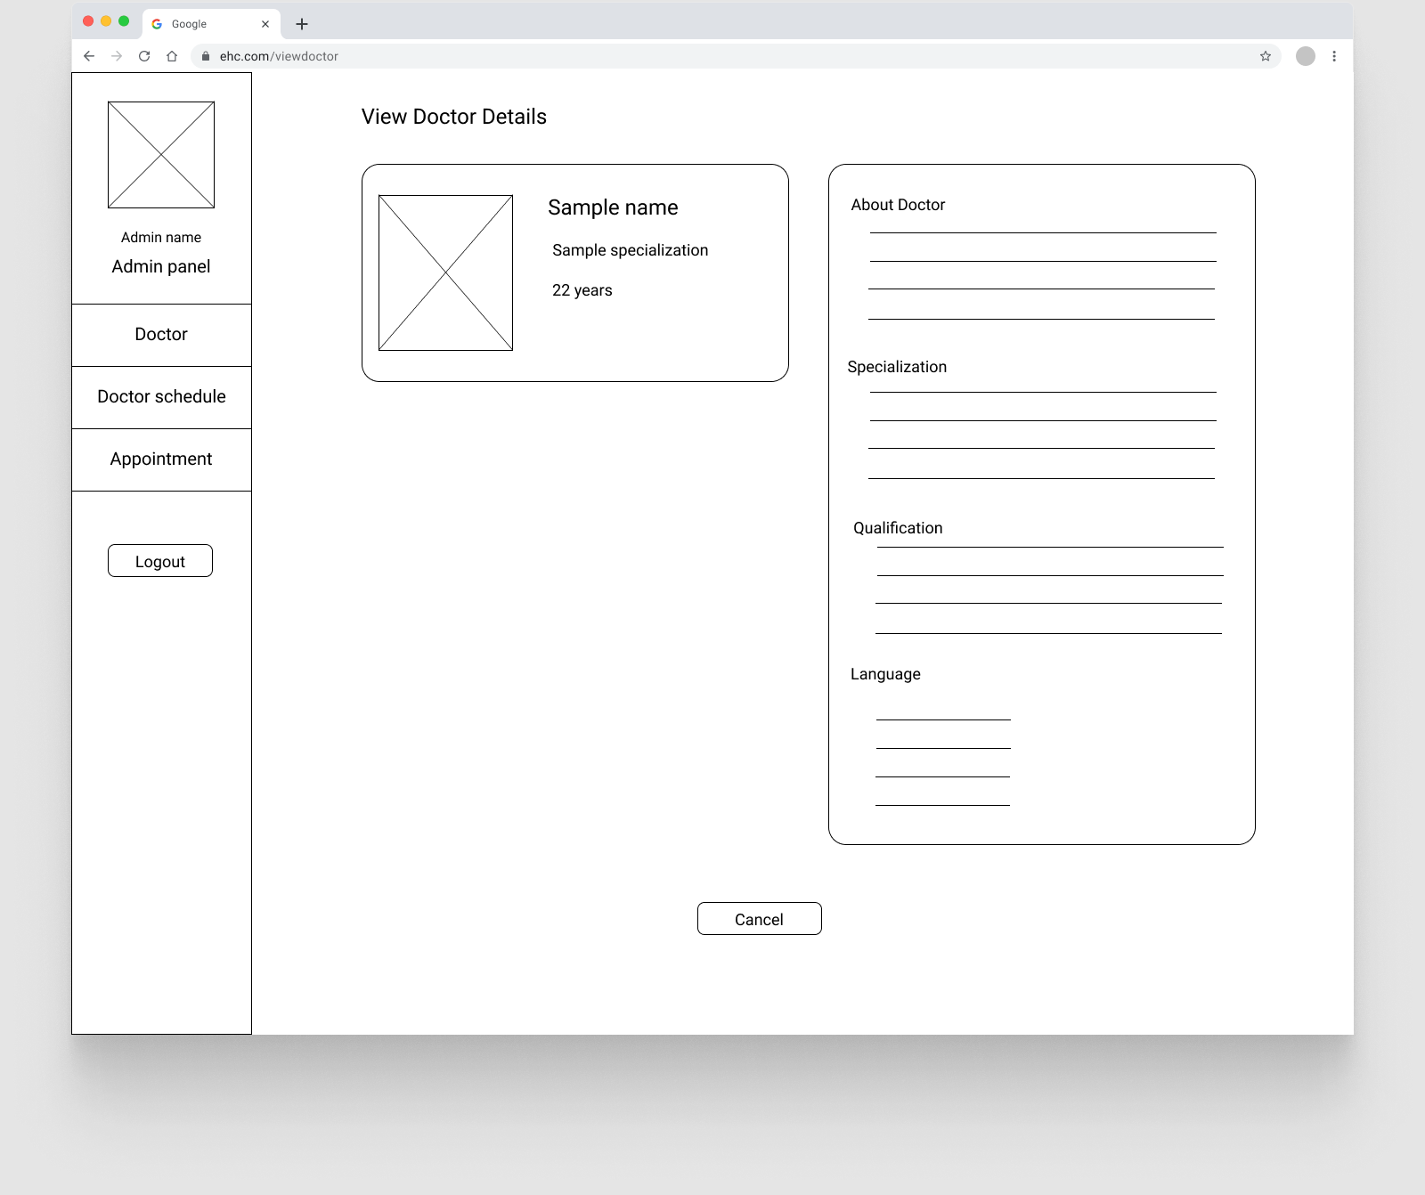

*Figure 2.2.5: View Detailed Doctor Information*

The cross box below the title is the doctor’s image. The language section should display one language in each row only.

**Doctor schedule list**

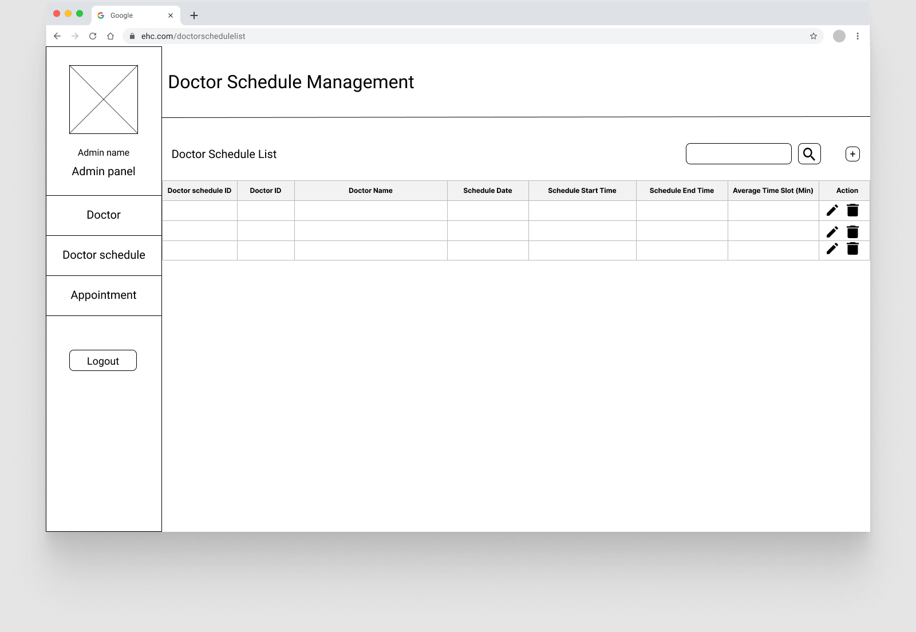

*Figure 2.2.6: Doctor Schedule List*

Below the main title, it contains a search box, followed by a submit button beside it and a link to the add doctor schedule form page. Below it should have a table to display the doctor schedule data, and it should be able to expand. In the row of the table, it should contain two buttons for edit and delete.

**Add doctor schedule**

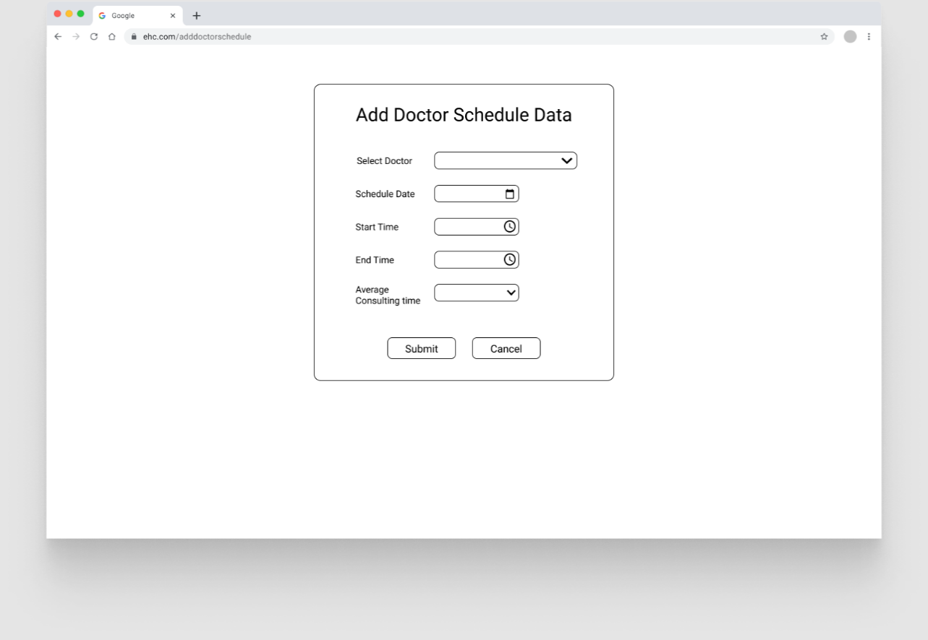

*Figure 2.2.7: Add Doctor Schedule*

This page form should provide two dropdown fields for selecting a doctor and average consulting time, date picker, and time picker for start and end time.

**Edit doctor schedule**

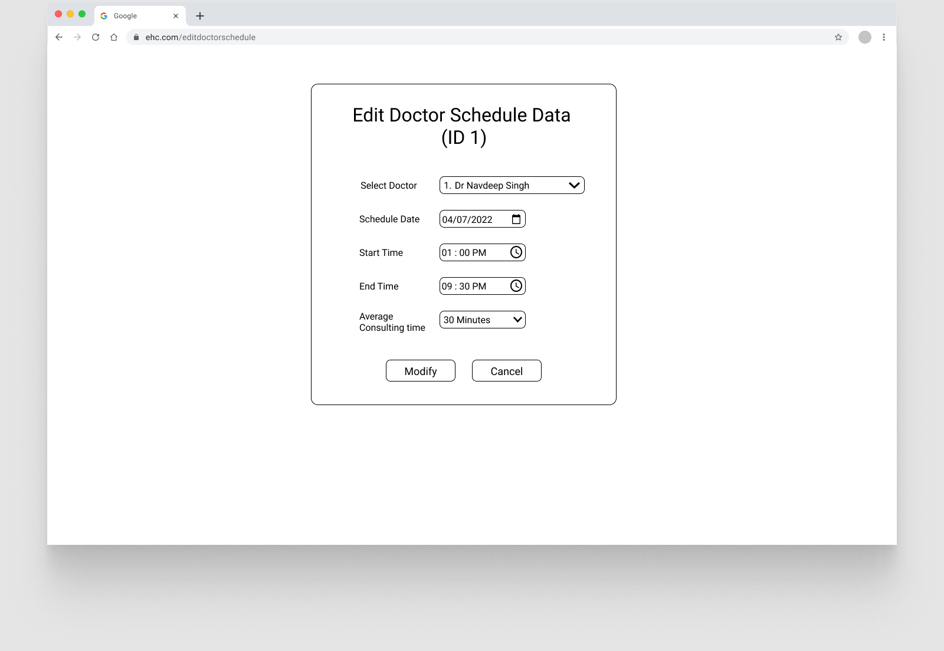

*Figure 2.2.8: Edit Doctor Schedule*

This page layout is the same as add doctor schedule page, and this page should be able to retrieve and auto-select the old data.

**\**

**Appointment list**

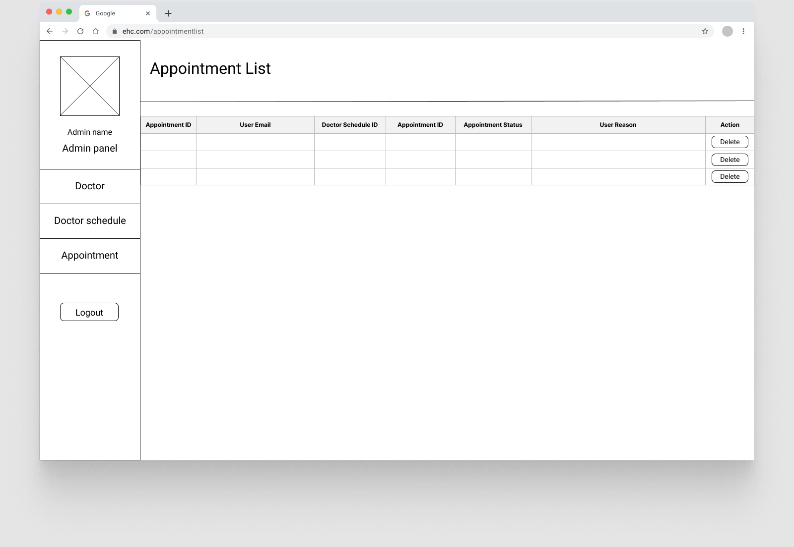

*Figure 2.2.9: Appointment List*

This page should have a table to display the appointment data, and it should be able to expand. In the row of the table, it should contain a button for deleting the appointment.

## Navigational Structure

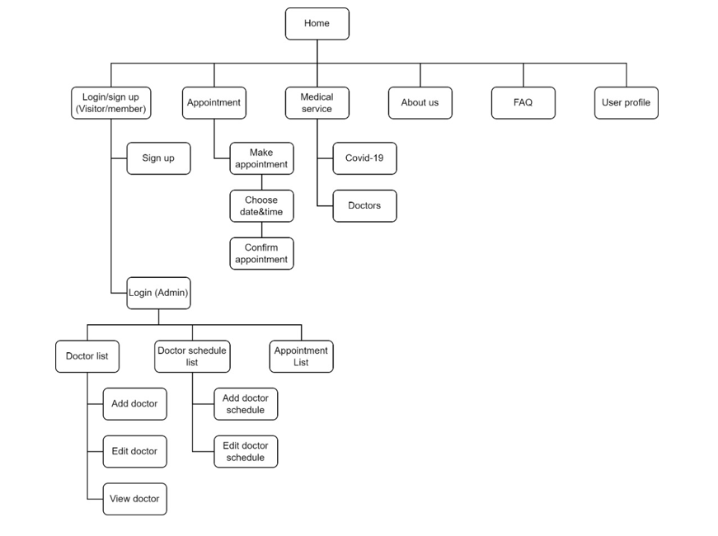

*Figure 3: Navigational Structure for Elderly Home’s Club*

## Activity Diagram / Flowchart

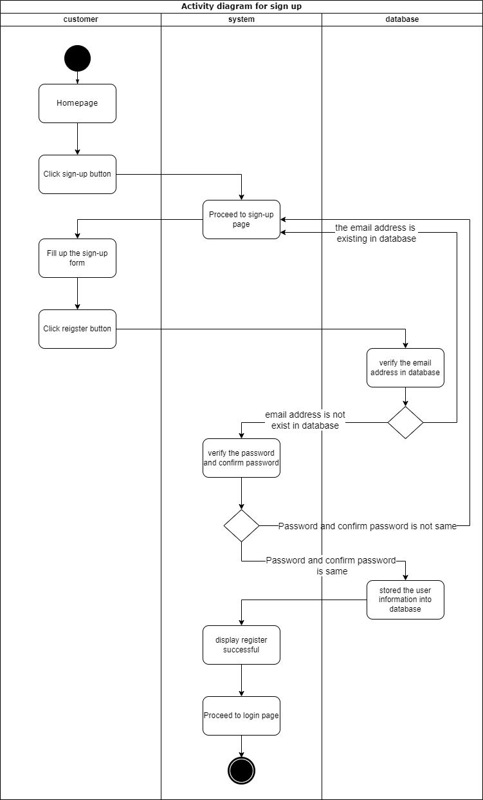

Figure 4.1: Signup

This process will be conducted by those customers who have not registered as users before. First, they will enter our homepage and there is a sign-up button on the top of the homepage. Once clicking the button, then the system will redirect to the sign-up page, and customers are required to fill up the sign-up form. After that, customers should click the register button once they ensure their registration information is correct. The form will be submitted to the database and the database will verify the email address that the customer inserted just now and confirm that the email address has not been registered before. If the email address is existing in the database, then the customer will be returned to the sign-up page in order to fill up the sign-up form again. If the email address is not registered before, then the system will verify the password and confirm the password in order to ensure that both are the same. If not the same password, then the page will be returned to the sign-up page also. After the verification process is done, then the customer data will be stored in the database and displayed registered successfully to the customer to let them know the registration process is done. The system will be redirected to the login page to let our users log in to the system.

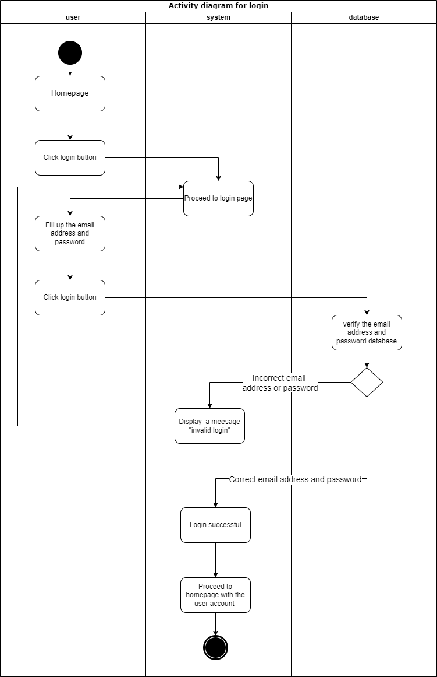

Figure 4.2: Login

After entering the homepage, users need to click the login button at the top of the homepage, and it will proceed to the login page. On the login page, users are required to insert their account email address and the password. Once the user clicks the login button, then the database will verify the email address and the password. If the password and email address are the same as the database, then the system will show login successfully and proceed to the homepage and show the user account at the top of the homepage. In contrast, the system will show invalid login and return to the login page.

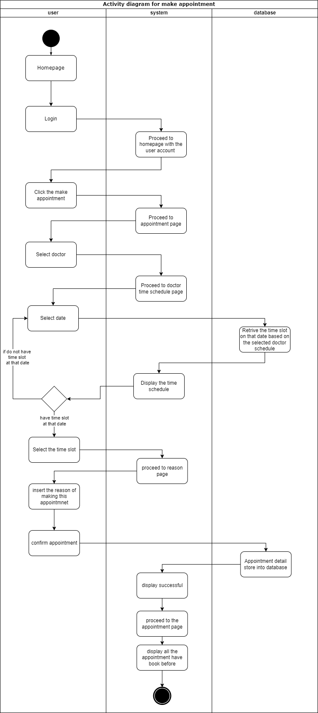

Figure 4.3: Make Appointment

If users want to make an appointment through our website, they should log in to their personal account on our login page. Once the login process is done, then they can proceed to the appointment page by clicking the “make an appointment” button and the system will display the appointment page. On the appointment page, users can select one of the doctors that we cooperate with, and the system will proceed to the doctor time schedule page. Users have to select a date and the date will be passed to the database to retrieve the time slot of the doctor on that date. If the doctor is not scheduling an appointment time slot on that date, then the user has to choose another date. Once the doctor has scheduled the appointment time slot on that date, the users can choose one of the time slots and the system will be redirected to the reason page. On the reason page, users are supposed to write the reason for booking this appointment so that the doctor can have a brief understanding of the patient situation. Once the user confirms the appointment, the appointment will be booked successfully and stored in the database. Therefore, the appointment page will show the appointment that users made just now.

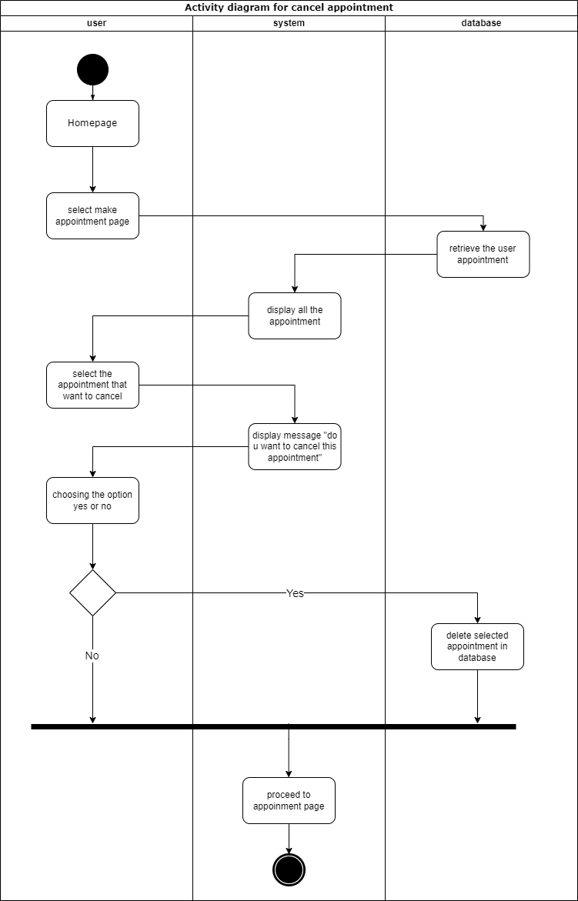

Figure 4.4: Cancel Appointment

If users want to cancel the appointment, then they also need to select the appointment page at the homepage, the database will retrieve all appointments that the user booked before and display them on the screen. Users can select an appointment that wants to delete and click the delete button beside the appointment. After that, the system will show a message to make sure that the user wants to cancel the appointment. If the users select “yes”, then the appointment will be cancelled and deleted from the database also. Last, the system will proceed to the appointment page again and this is the overall process of cancelling an appointment.

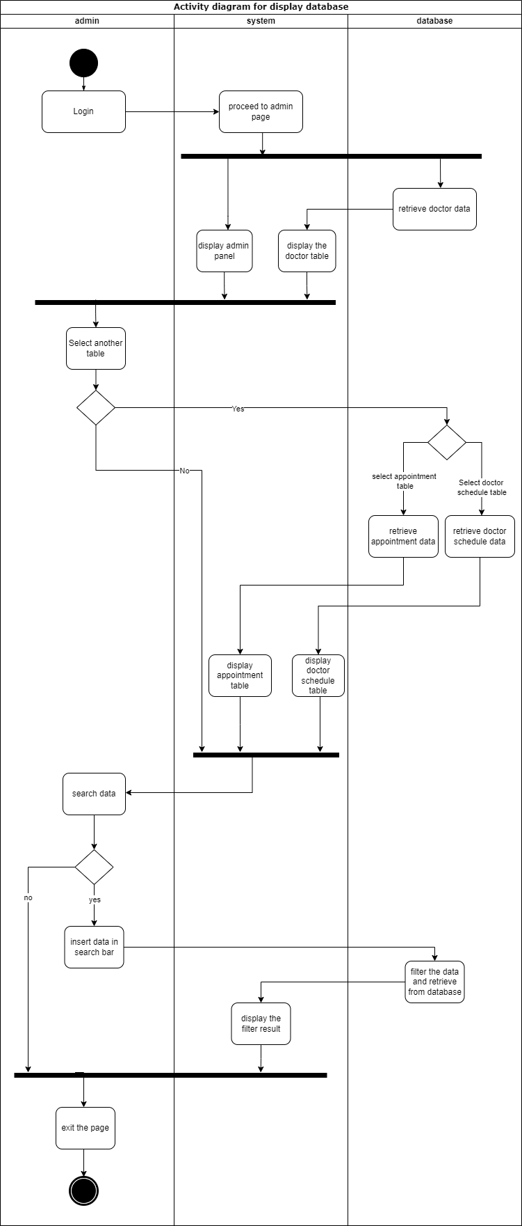

Figure 4.5: View Data

If the admin wants to view the database on our website, they have to log in to their admin account and proceed to the admin page. In admin pages, there are two components, one is the admin panel, and another one will be the doctor table which retrieves the doctor data from the database. So, if the admin wants to see another table, then they can select another two more table which is the appointment and also the doctor's schedule. After admins select the table that wants to view, then they can use the search function to find out the specific data. They just need to insert the data in the search bar and the database will automatically filter the data and retrieve all the relevant data from the database. The filter result will be shown in the table.

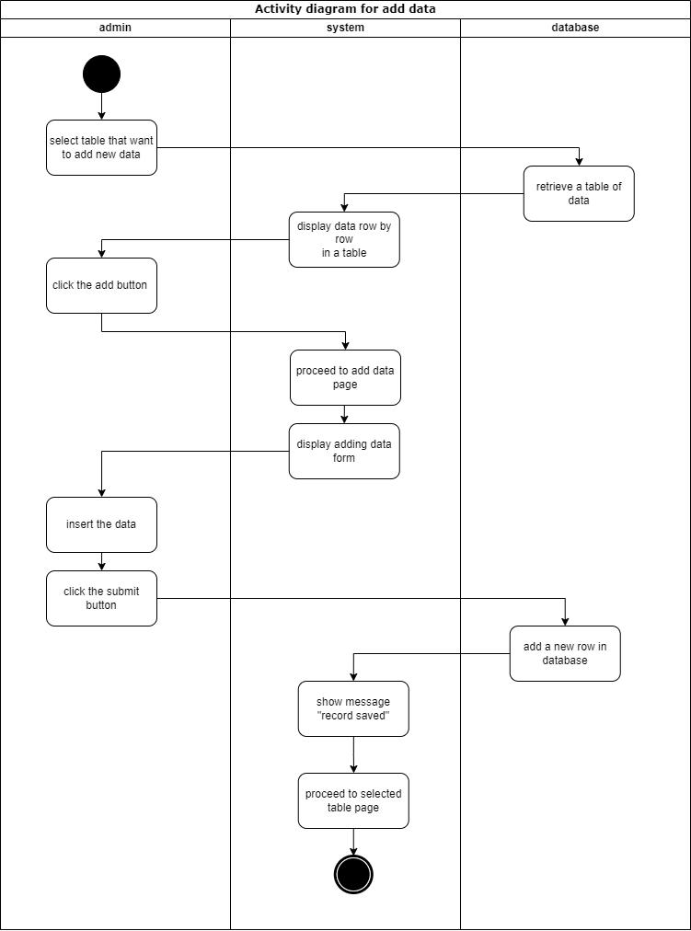

Figure 4.6: Add New Data

Admins must select the table that wants to add new data first on the admin panel. Once select a table, the data of the table will be retrieved from the database and displayed on the screen. There is an 'add' button on the screen and click on it, the system will proceed to the add data page, which is included a form that can insert data into the database. Admin can insert data into the form and submit it. Then, the form will send to the database, and add one new row of data to the table. Once the data have been inserted into the database, the system will show a message to indicate the data is saved in the database and proceed to the table again and the admin will notice the row data is showing in the table.

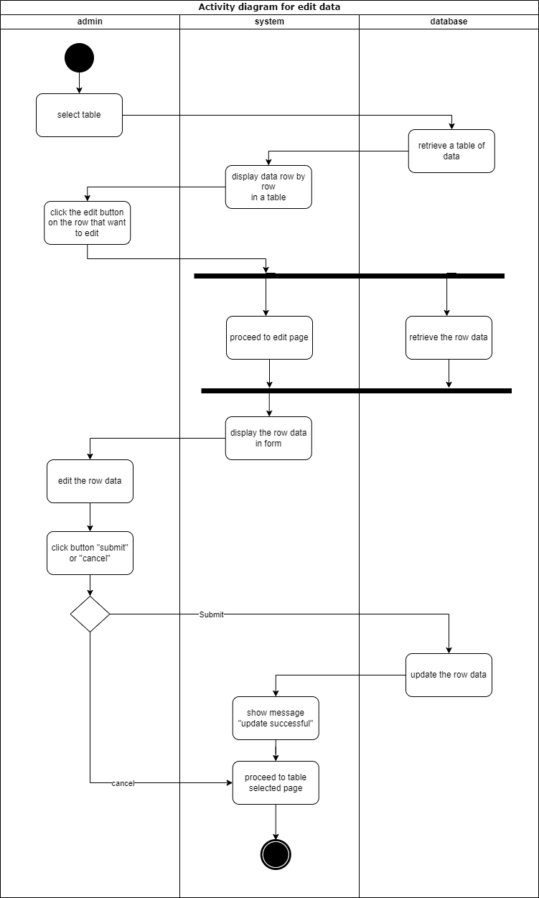

Figure 4.7: Edit Data

Admins select the table that wants to edit, and the system will retrieve all the data from the table and display it row by row in a table form. Admin can select and click the edit button on the row data that want to edit. The system will proceed to the edit page and retrieve the row data from the database at the same time. On the edit page, the selected row data will display this form and the admin is allowed to edit the data inside the form. Once the data has been changed, the admin can click either submit button or the cancel button. If the admin clicks the submit button, then the row data will be updated accordingly, and the system will show the updated successfully message at the top of the pages. Last, the website will redirect to the table selected at the beginning.

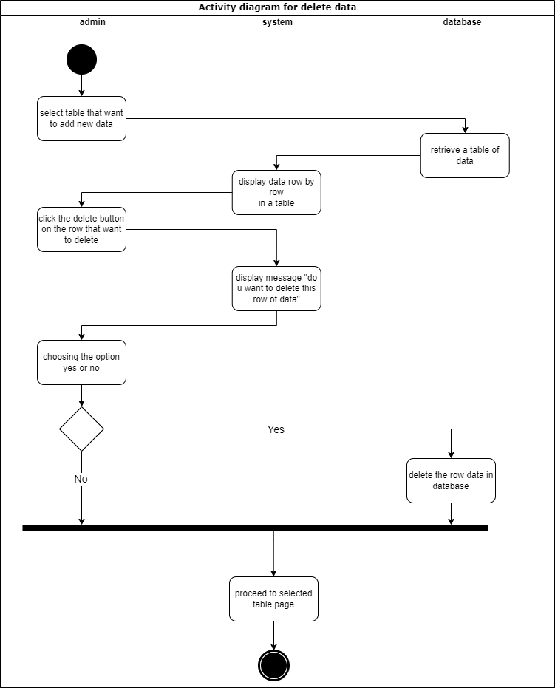

Figure 4.8: Delete Data

This process will be similar to the edit data process, at the beginning, admins have to select a table, and the data of the table will be retrieved and displayed on the webpage. There is a delete button at the last of the row of data. Once the admin clicks the delete button, the system will display a message to confirm if the admin wants to delete the row data in the database. If the admin chooses “yes”, then the row data will be deleted immediately from the database. Last, the system will proceed to the selected table page in the beginning.

## Entity Relational Diagrams (ERD)

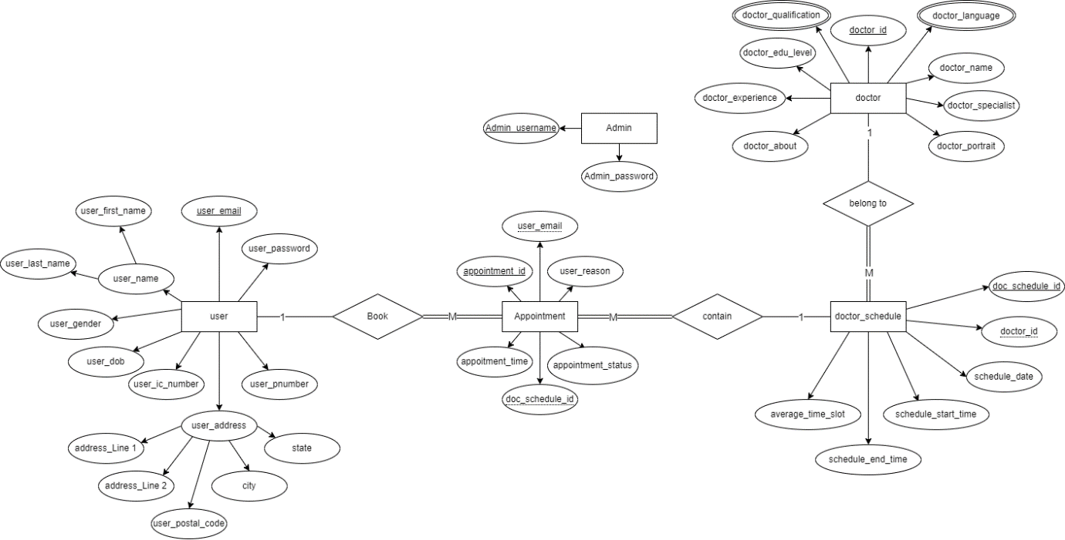

*Figure 5: Entity Relational Diagrams (ERD) for Elderly Home’s Club*

# Implementation

## Create

**Add Doctor (HTML form)**

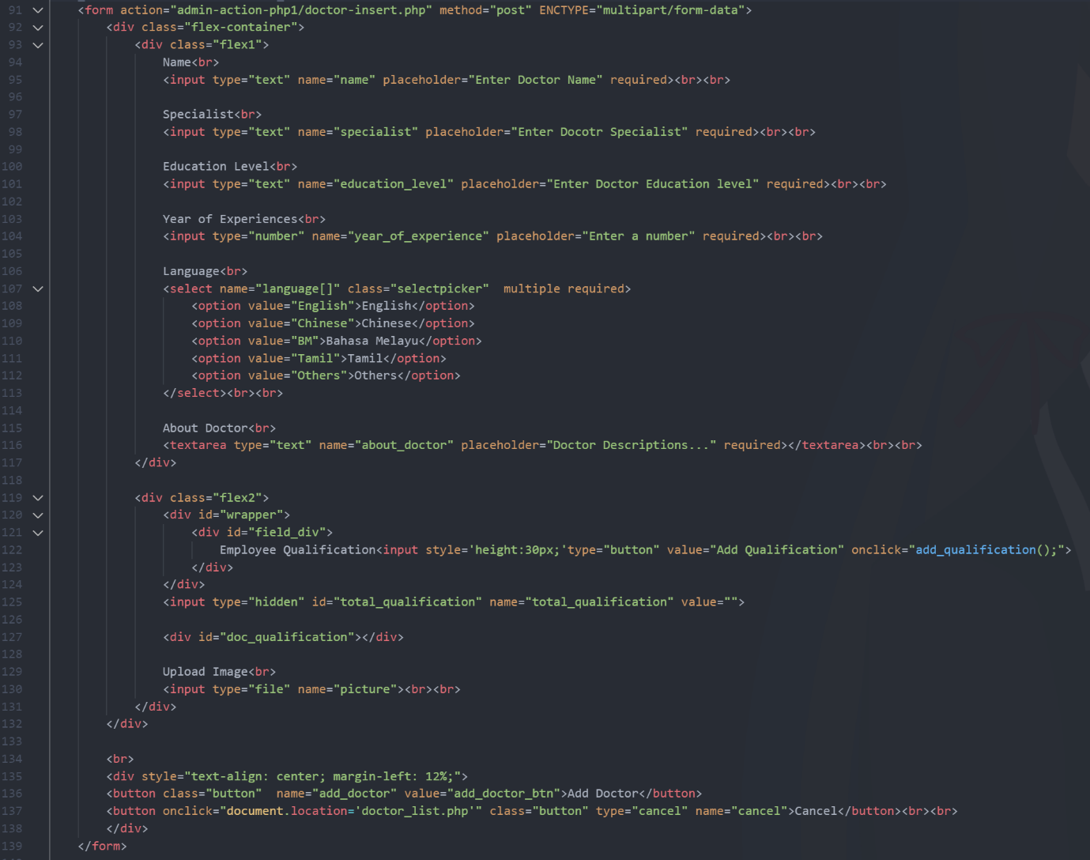

*Figure 6.1: Add Doctor HTML*

To create or add a record to the database, we need to retrieve input from the user first. The HTML form and its element is a way to obtain input. We start this part by using the HTML form tag in our code. Inside the HTML form tag, we specified where we wanted to send the form retrieved data in the action attribute, the “doctor-insert.php” file, and the method attribute we chose to use is the post method. Using the post method, the user cannot see and change the data passed in the URL. Besides, because our form is expected to receive a file from the user, we specified the “enctype” attribute as “multipart/form-data”.

Skip the div tag used to style the table. The crucial part is the HTML elements, including input, select, textarea, and button, which are used to obtain data and action from users. In line 95, we use an HTML input tag, and we specify the element’s type of this input tag which is text, using the “type” attribute. The element’s type of the input tags we specified in this code snippet includes text, number, hidden, and file. By specifying the input type, the website will provide the most appropriate input field to the users.

Besides input type, we also use some other attributes in the input tag. For the “name”, “placeholder” and “required” attributes, in the code snippet, we assigned “name”, “specialist”, and more to the “name” attribute. We use the “name” attribute as a variable or a box that can store the value received from the user and allow us to manipulate the data in the later PHP part. We use the “placeholder” attribute is just used to provide a hint to the user, and the “required” attribute forces the user to fill up the field to submit the form.

In line 107, we use an HTML select tag, and its attribute is similar to the input tag. Skip the class which used to perform styling. The highlight attribute is “multiple”. Because the doctor might have several language uses, this section is set to receive multiple values using the “multiple” attribute. In addition, using the square bracket at the end of the “name” attribute can pass these multiple values as an array to the later PHP part. Besides, because this is a selection section, the user is not required to type in values and only choose options. Therefore, we need to set the corresponding value for each option provided.

In line 116, we use the textarea tag to receive multiple lines of text, which is about doctor information from users. In line 122, the input tag is set to execute a javascript function when it is clicked. In line 125, we use the hidden type of input tag associated with the code in line 122, and users will not be able to see the hidden input tag. In line 130, we use the file type of input tag, it is used to let the admin upload the doctor’s picture, and a name is assigned to do manipulation later. In line 136, the button is used to pass this form data to the PHP file we specified in the form action attribute. In line 137, the button is used to back to the previous page, the doctor list.

**Add Doctor (PHP)**

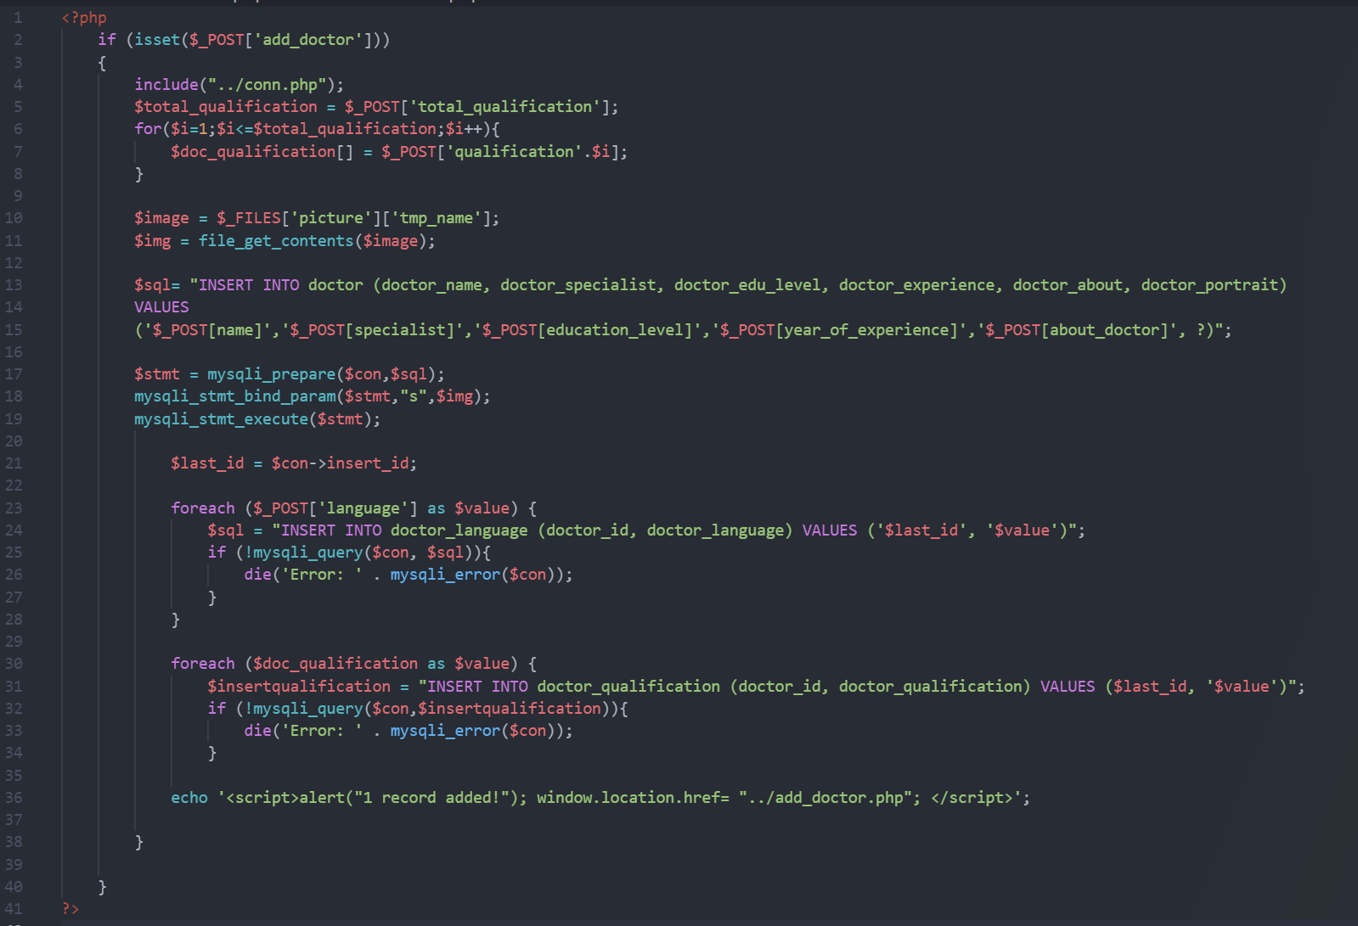

*Figure 6.2: Add Doctor PHP*

In the add doctor PHP code, we start by identifying whether the user clicks the button in figure ? line 136 or not. If they click, the name of “add_doctor” will be set, and the following action will be executed to store data and create a new row in the doctor table. First, we create a connection to the database in line 4. Then, we process the received data starting from the doctor’s qualification. In lines 5 to 8, we get the user input qualification amount hidden in the HTML form before and start a for loop to retrieve the value and store it into the “$doc_qualification” list. In line 10, the “picture” doctor picture is retrieved and assigned with a temporary name. After that, it is read into a string (w3schools, n.d.).

In lines 13 to 17, we prepare a SQL query used to create a new record in the doctor table. The highlight is that in line 15, the last parameter in the SQL statement is unspecified. In line 18, we bind the “picture” doctor picture into the unspecified parameter created before as a string (“s”). After that, we execute the prepared SQL query in line 19. Till here, the new doctor record in the doctor table has been created, but the doctor language and doctor qualification are still ongoing. We need to retrieve the corresponding doctor id to store the remaining data.

Therefore, we retrieve the last auto-incremented id from the last query in line 21. In line 23, because the doctor language has multiple values stored in an array, we use the “foreach” loop to access each value in the array. Each value in the “language” array will execute lines 24 to 27, including the SQL query in line 24 and the database error alert in line 26. The SQL query can record the last auto-incremented id and a language in the doctor language table.

For the doctor qualification part, the lines 30 to 34, the structure and logic are the same as the language part. The only difference is the destination table and the actual value. Lastly, the code in line 36 is used to pass the user back to the add doctor page after the record is saved.

## Read

**Doctor Schedule List (HTML form)**



*Figure 6.3: Search Doctor HTML*

On our doctor schedule list page, we provide a search box using an HTML form. It is used to provide a better reading experience to the users. In our code, it is a simple component that consists of one form with an input field and a submit button. However, we did not specify the action attribute in the form tag because the form will pass the data to the PHP code on the same page.

**Doctor Schedule List (PHP)**

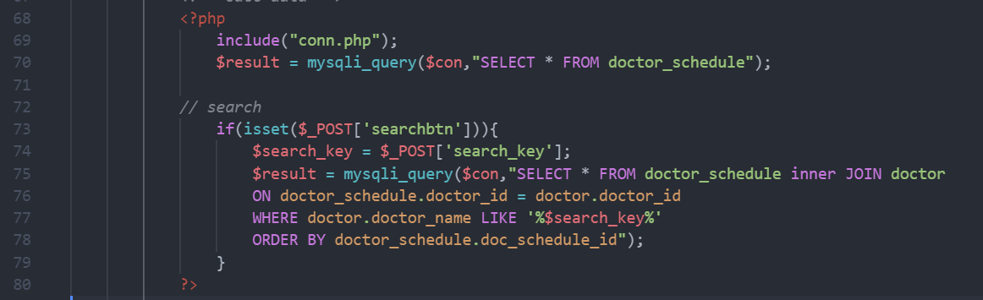

*Figure 6.4: Search Doctor HTML*

In the PHP data retrieve part of our doctor schedule list. We start by connecting to the same database. By default, we select or retrieve all data from the doctor schedule table using SQL query in line 70. However, if the user submits some information using the search box, the if statement in line 73 will become true and execute the following code. First, it stores the received data to a variable called “$search_key”, and then we use a SQL statement to select the data that match the user’s search. In this SQL statement, we join two tables using the “INNER JOIN” syntax and make sure they join with the correct condition by using the “ON” syntax. The highlight of the SQL statement for search is the “WHERE” and “LIKE” syntax. Here we compare the data in the database with the user-given information and produce relevant search results.

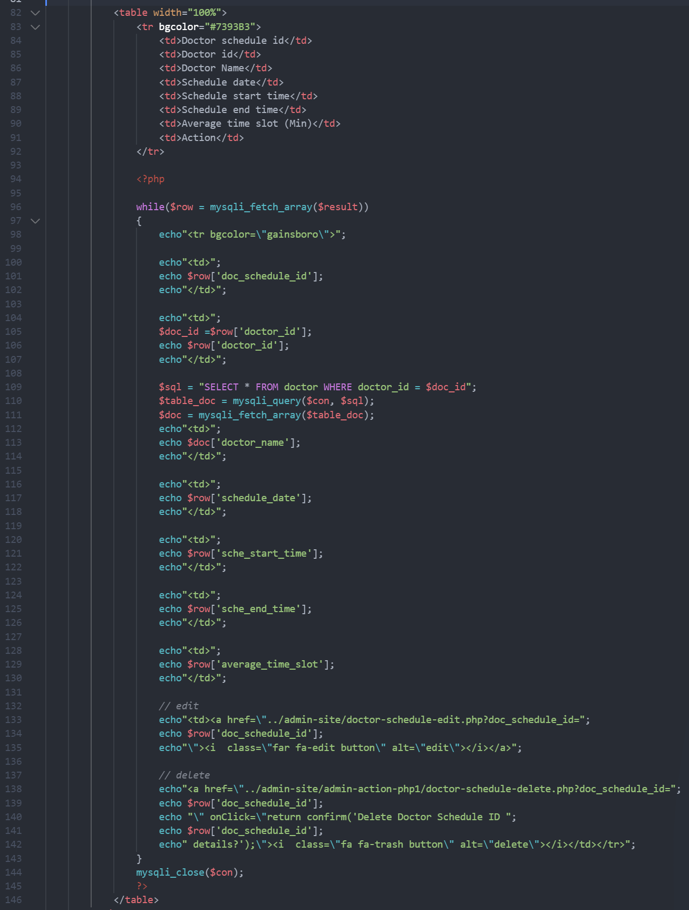

*Figure 6.5: Read Doctor HTML and PHP*

After we retrieve the correct data set, whether the user uses search or did not, we display the data in the same HTML table. Lines 83 to 92 are the first row of the table, and it is the table’s heading. It is static and therefore does not involve PHP code. Lines 96 to 130 is where we display the data, and line 133 to 143 is used to create buttons that allow the user to perform the edit and delete action on the corresponding data row. The “$result” variable in line 96 stored the array retrieved in the previous SQL section, and it might contain multiple arrays. Therefore, we use the while loop and the mysqli_fetch_array() function to read the array. After that, each array in the “$result” variable will involve in the following code execution.

To create a row for displaying the data, we first use the HTML “tr” tag in line 98 and end it in line 142. Inside the “tr” tag, we use several “td” start and end tags to provide data containers inside the row. After containers are there, we display the data retrieved using echo and the variable we set in the while loop associated with the particular table’s column name.

## Update

**Edit Doctor Schedule (HTML form and PHP)**

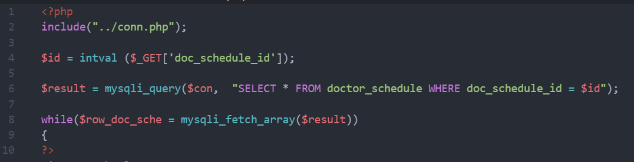

*Figure 6.6: Get Doctor Schedule Data PHP*

We first retrieve the old record from the database using SQL query and use a while loop to access the array in the update part.

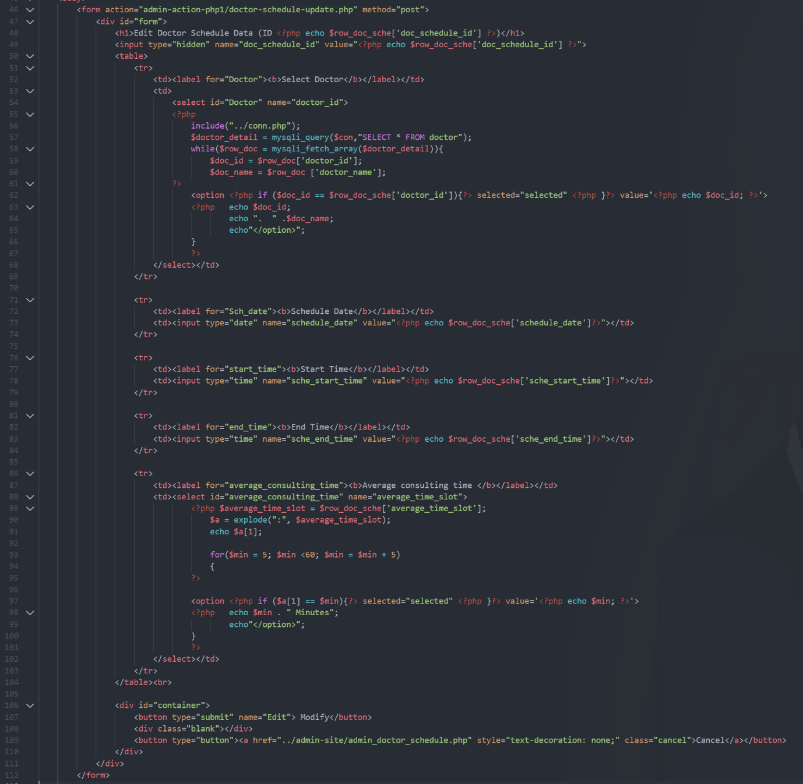

*Figure 6.7: Edit Doctor Schedule HTML and PHP*

After we retrieve the row of old data, we place it in the value attributes of the HTML form elements, such as input type “text”, “hidden”, and “date” using PHP. Therefore, the input field will be auto filled, and the user only edits the part they want and does not need to retype.

In lines 54 to 67, we make a select section that includes each doctor’s name and id, all doctors will be shown, and the selected doctor by the previous button in the doctor schedule list will be automatically selected. In lines 88 to 102, we make a time slot selection using PHP, HTML select, and option tag. It will provide a 5 to 55 minutes slot for the user to choose from.

This HTML form specified the action attributes that we want to pass the data to the “doctor-schedule-update.php” file.

**Edit Doctor Schedule (PHP)**

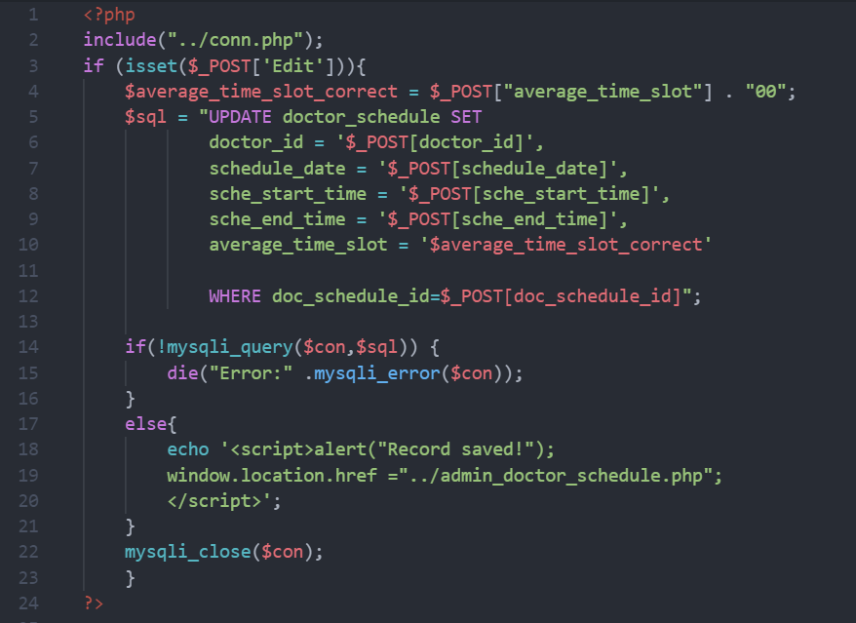

*Figure 6.8: Update Doctor Schedule PHP*

After the user clicks the submit button on the edit doctor schedule page. The data will be posted to this code snippet. We start this code by connecting to the database and identifying whether the user did click the submit button or not. If the if statement is true, we reformat the time slot and create a SQL statement which is used to update the data in the table using “UPDATE”, the table name, “SET”, and the previously posted data, and “WHERE” to select the correct row.

In lines 14 to 21, the if-else statement is used to print the database error if it exists, and if there is no error, it will redirect the user back to the doctor schedule page.

## Delete

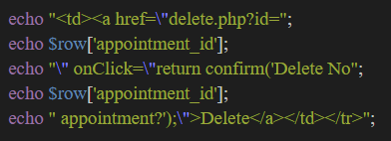

*Figure 6.9: Delete Button PHP*

As shown in Figure 6.9, the "Delete" button is placed in the table column. The button is linked to 'delete.php' to operate in the first line. Before the user confirms the deletion of the data, there is a prompt box showing "Delete No" and the specific "appointment_id".

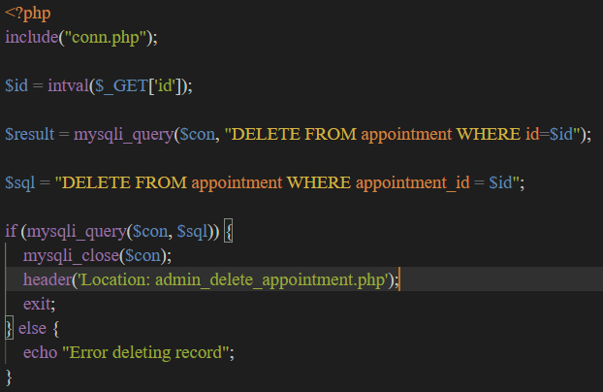

*Figure 6.10: Delete Appointment PHP*

As shown in Figure 6.10, the administrator can delete one or more appointments by clicking on the delete button displayed in the column. If a "delete" operation is required, it must connect to the database (including conn.php). Using ‘intval’ to ensure that the value return is integer. Next, after getting the "id" from figure 6.9, it will delete the specific data and rows. If the deletion is successful, then it will close the connection to the database (mysqli_close($con)) and return to the appointment page. Otherwise, it will display an error message.

## Login

*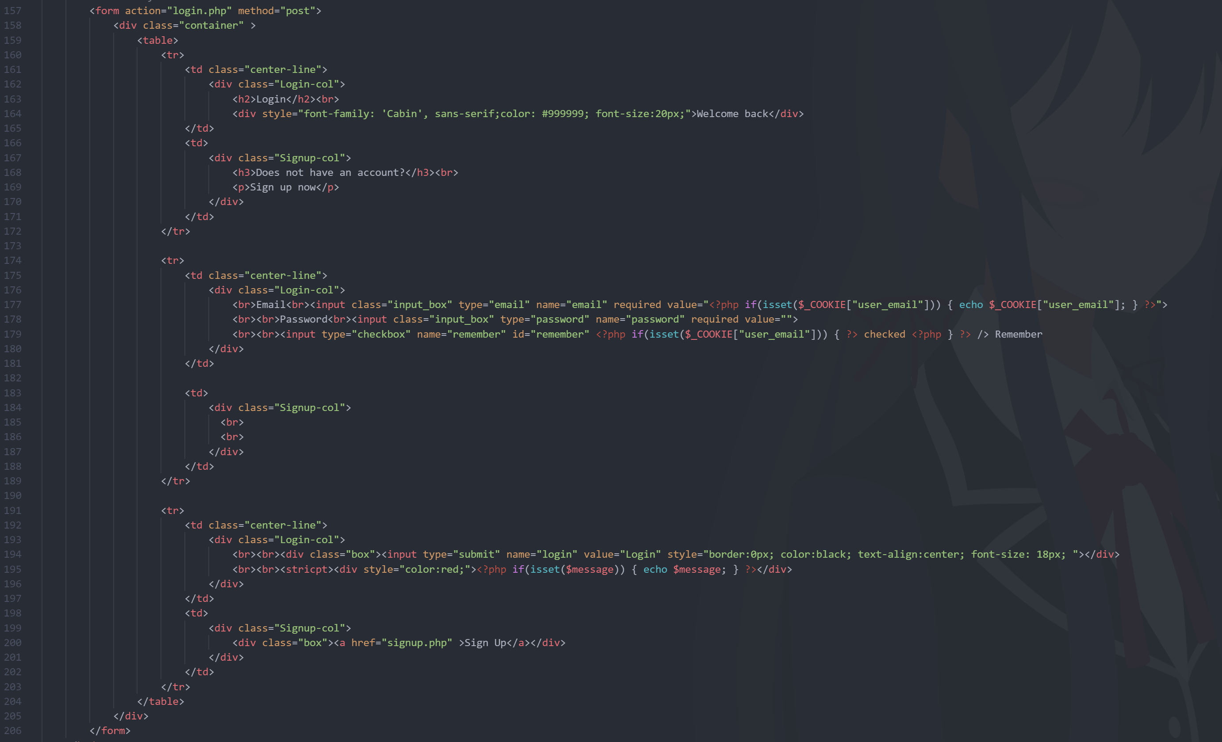Figure 6.11: HTML for login*

For the login section, there are several fields waiting to be filled in, such as email and password. Use the 'post' method so that the user cannot see and change the data delivered in the URL. These two inputs are mandatory, and the user cannot log in without filling one of them in. After filling in all the fields, the user can tick the "Remember" box. If there is no account, the user can click on "Sign Up". All the actions will be executed in the following PHP (Figure 6.12).

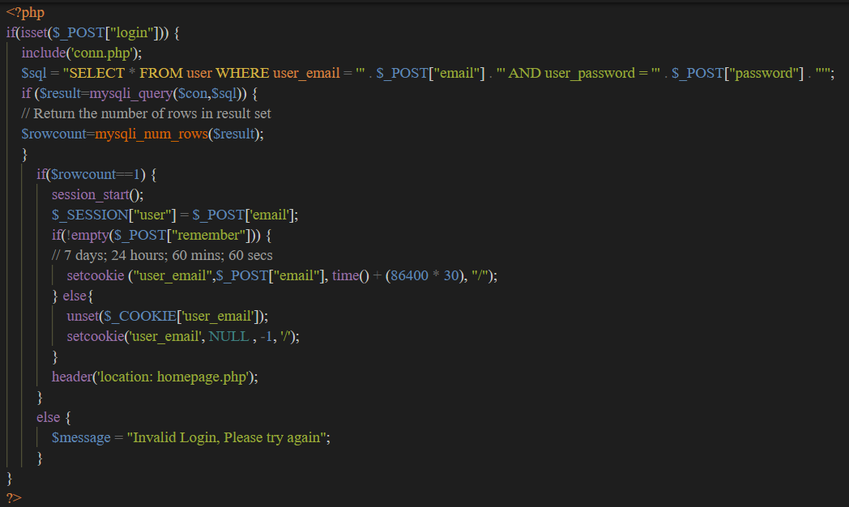

*Figure 6.12: PHP codes used for login*

As usual in PHP, in Figure 6.12 we had connected to the database (including conn.php). Next, if the login request method is posted and it is not a null value, then the PHP code will execute. First, set up a SQL query to select all the data from the ‘User’ table, where the email and password in the database match the user's input. After that, the SQL query result will be stored in $result. Then, $rowcount as its name implies will count and store the number of rows of the $result. If the $rowcount is equal to one by using the “==” comparison operator, the session will start and the $_SESSION[“user”] will equal value with the email. Not only that, if the user clicked the ‘Remember’ in Figure 6.11, it will set a 30day cookie for the user. Else, it won’t set it. After doing all the actions, the user will be redirected to the homepage.php page. If the $rowcount is not equal to one, it will prompt a message “Invalid login. Please try again.”

## Signup

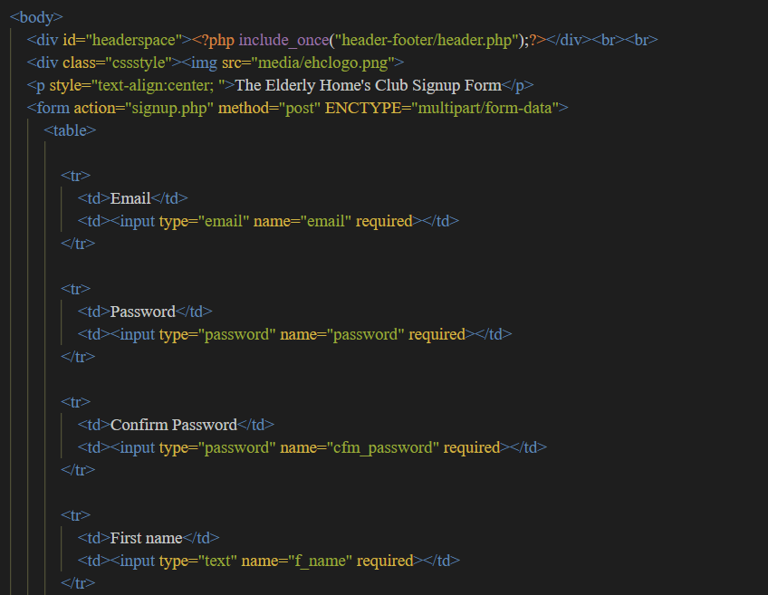

*Figure 6.13: Form for Signup*

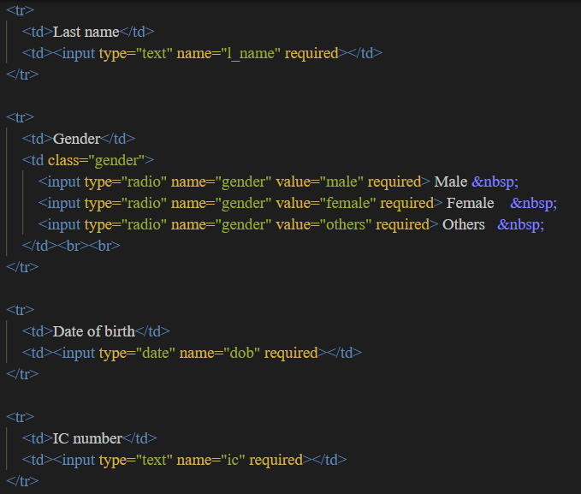

*Figure 6.14: Form for Signup (Cont.)*

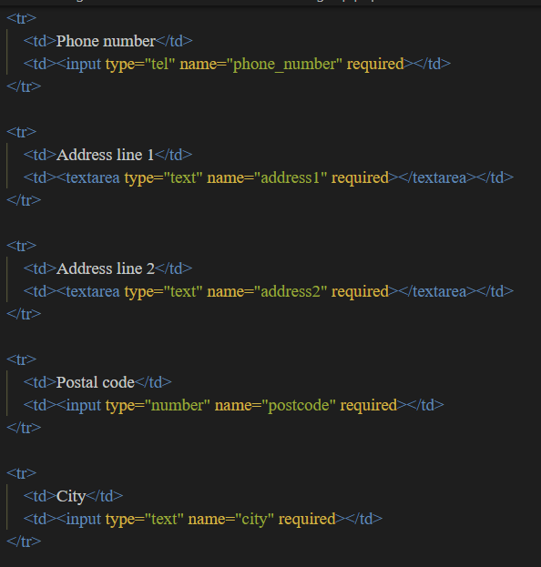

*Figure 6.15: Form for Signup (Cont.)*

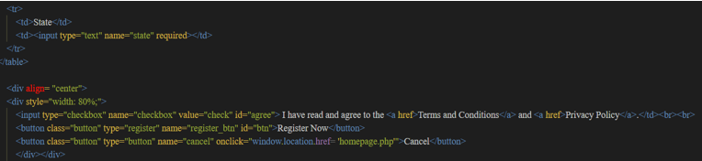

*Figure 6.17: Form for Signup (Cont.)*

First, in this HTML form, the "ENCTYPE= multipart/form-data" specifies how the data will be encoded before being sent to the server. Also, use the post method to prevent data from being changed by changing the URL. From Figure 6.13 to Figure 6.17, there are many columns that have users fill in. Such as email, password, name, address, gender, etc. The user must fill in all the columns in order to proceed to the next step because with ‘required’. For gender, radio buttons are used. Because the address will be more data to enter, thus it is using ‘textarea’ instead of ‘input’. All the sign-up actions will be performed in Figures 6.18 and 6.19. Before that, if the user clicked the ‘Cancel’ button, the URL will be returning to ‘homepage.php’.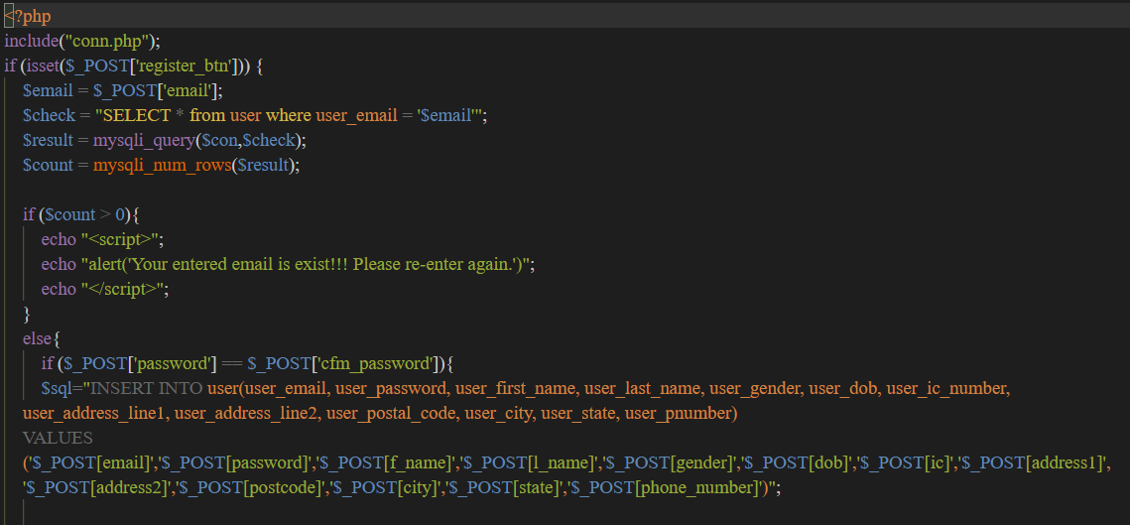

*Figure 6.18: PHP for Signup*

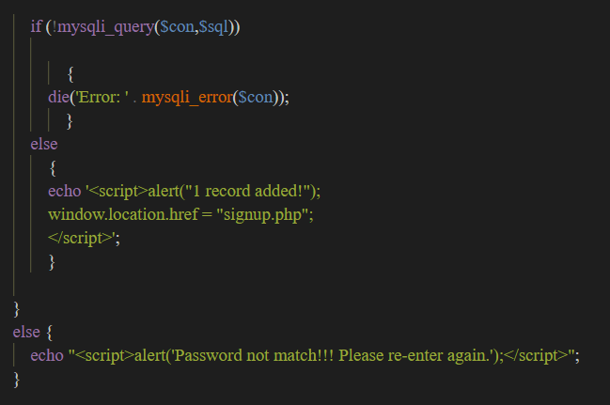

*Figure 6.19: PHP for Alert box*

As always, the connection database is the first step. If 'register_btn' does not return a null value, $email will store the email entered by the user. Use to check email have or haven’t existed, $check variable will select all from the database by using the email. $count will count and store the number of rows of the $result. If $count more than 0, an alert box will be shown. Else, use $_POST to get two values from the HTML form and compare, them when both of them are the same. Then using the insert query insert all the values read from the HTML form and store them in the ‘user’ database. As Figure 6.19 shown, if connection to database error [! mysqli_query ($con, $sql)], it will terminate the connection. If not then, ‘1 record added’ will be alerted in signup.php. For the password does not match, it will prompt ‘Password does not match!!! Please re-enter again.’

## Self-created CSS and JavaScript

**CSS Style**

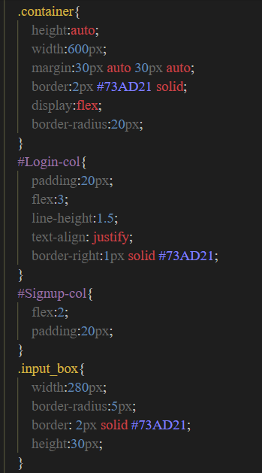

*Figure 6.20: CSS Codes*

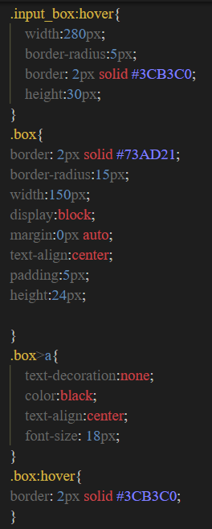

*Figure 6.21: CSS codes (Cont.)*

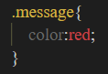

*Figure 6.22: CSS codes (Cont.)*

The CSS code helps us to adjust or change colours, borders, positions, backgrounds, etc. as shown in Figures 6.20 to 6.22. By using the correct selectors, all HTML and PHP can be styled. For example, ‘.container’ is the class name for Figure 6.9, using the height, width, margin, and border to style the container in the right position and right design.

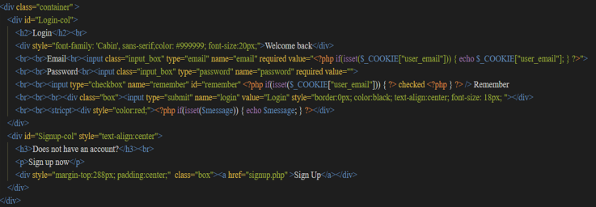

*Figure 6.23: HTML, using CSS to display content*

In CSS, there are two types of styles, inline and divisional classes. Divided classes make it easier to style all HTML or PHP that has the same class name, for example, "input_box". There is no need to insert the same style every time. For inline styles, it will be more specific to that line. If both exist, the inline style will take precedence over the divisional class.

**JavaScript**

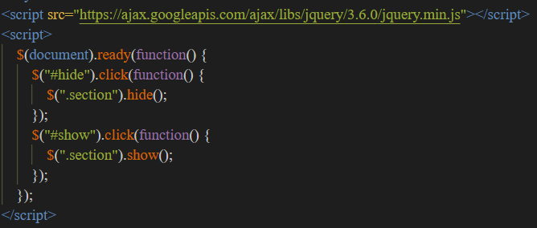

*Figure 6.24: JavaScript for Hide and Show Function*

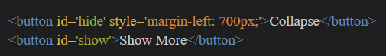

*Figure 6.25: Collapse and Show More Button*

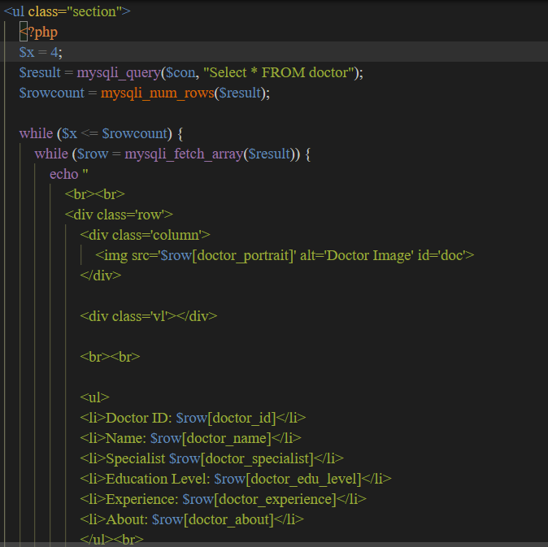

*Figure 6.26: Section that using JavaScript*

Hide and show functions are part of jQuery Effects. These functions will hide and show the fifth line [$(". section"). hide();] or the eighth line [$(". section"). show();] for the specific section mentioned (.section). These hidden and shown parts are shown in Figure 6.26. As its name implies, the section will be hidden when the user clicks on the ‘Hide’ button and will be displayed when the user clicks on the ‘Show’ button.

# Main Section (User Guidance and Sample Screen)

## General Functionalities

**Homepage**

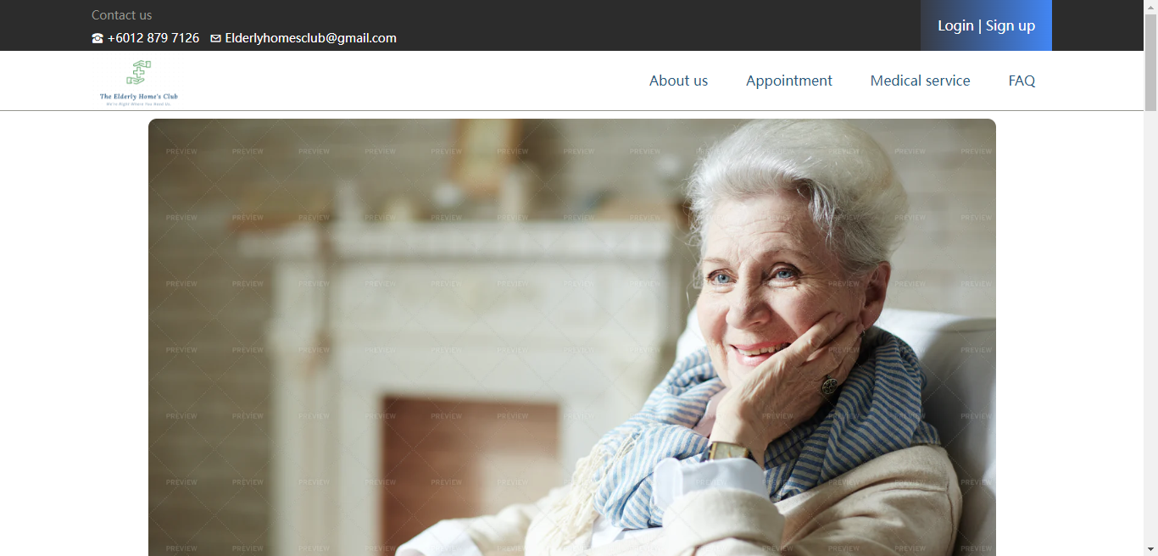

*Figure 6.1.1: General Homepage Interface*

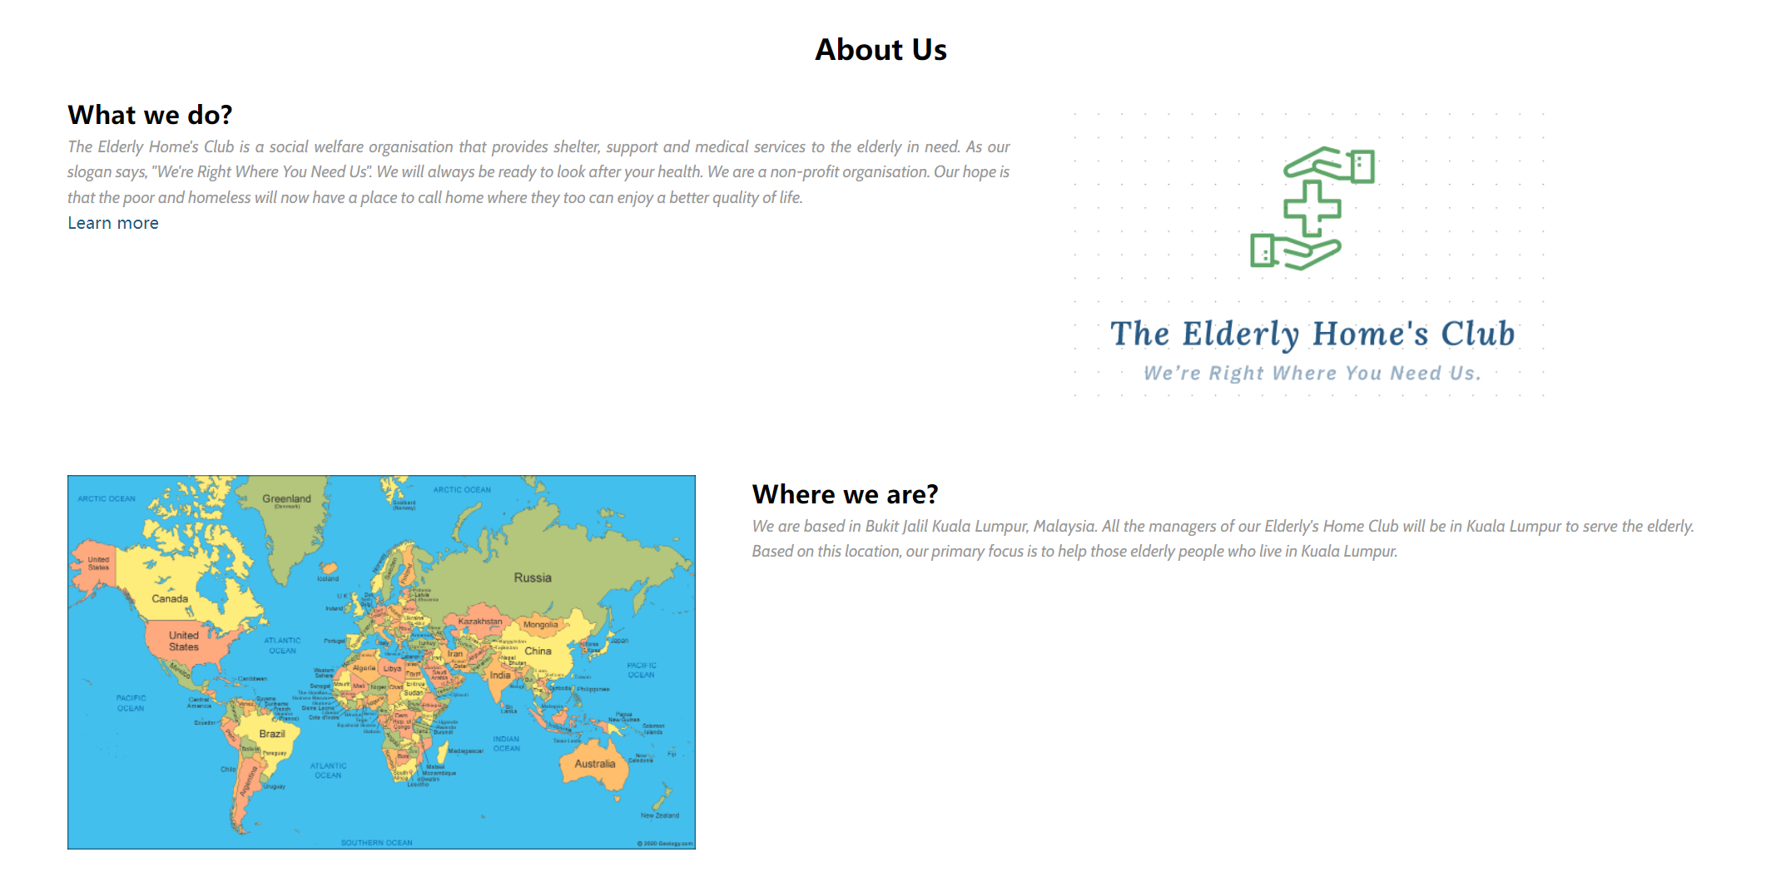

*Figure 6.1.2: General Homepage Interface with Brief About Us*

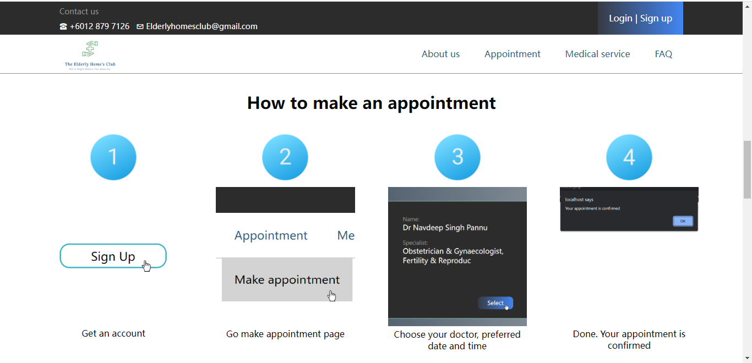

*Figure 6.1.3: General Homepage Interface with Steps to Make Appointment*

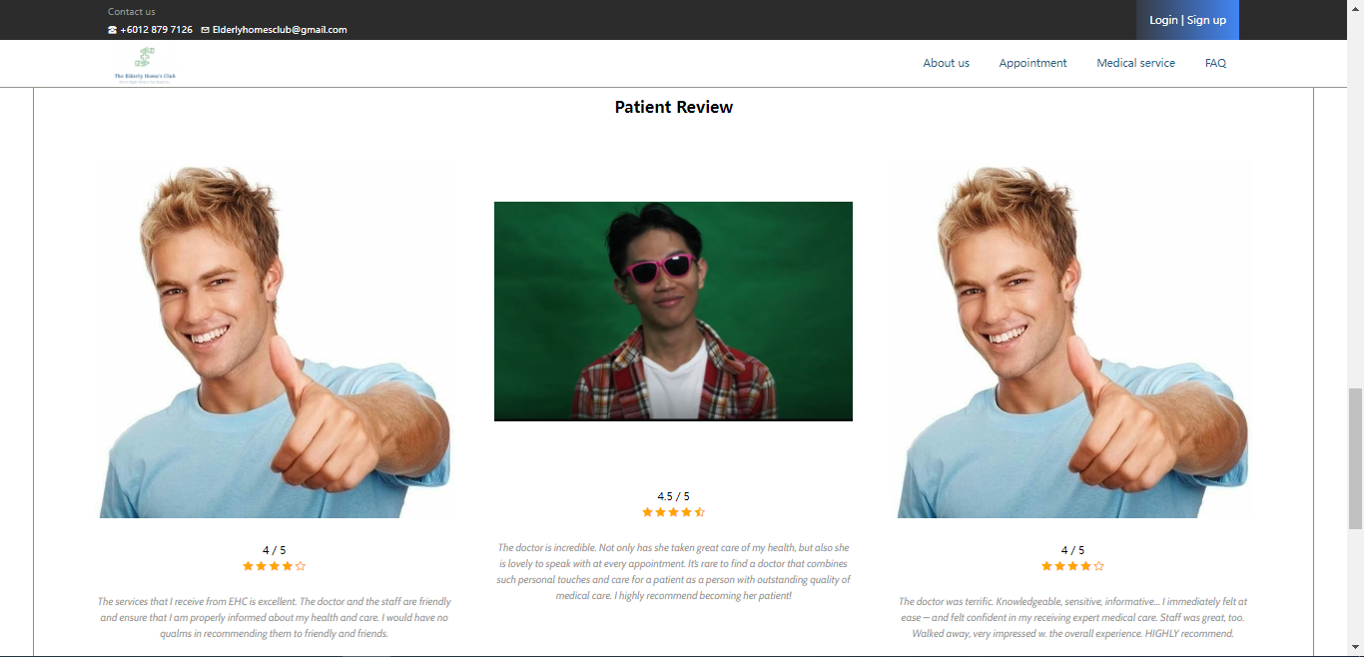

*Figure 6.1.4: General Homepage Interface with Patient Review*

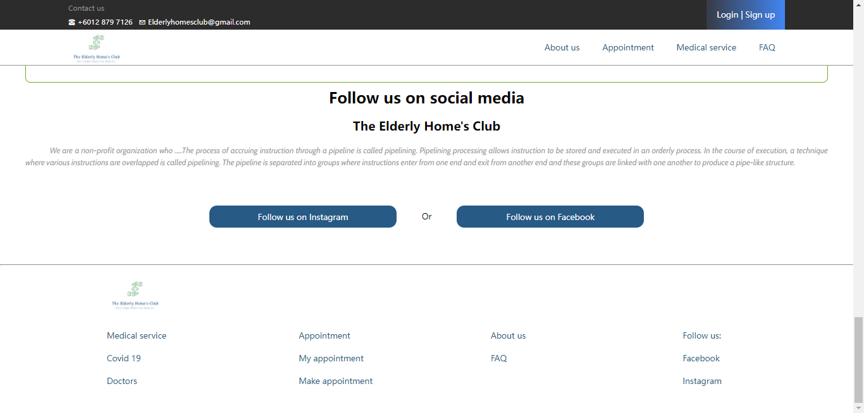

*Figure 6.1.5: General Homepage Interface with social media and Footer*

The home page is the first page that will be entered by the user when they browse the Elderly Home’s Club webpage. A piece of general information regarding the Elderly Home’s Club will be displayed on this page to engage the medical care services as well as provide a better understanding of the job scope for the guest. The homepage included 5 main content such as about us, location, steps to make an appointment, patient reviews, and social media promotion.

         Since there are 5 main contents on the homepage, the guest will need to go through all the homepages by scrolling down. The first content is about us which displays brief information and our location on the homepage. The guest can click on learn more at the last word of ‘what we do’ to direct to the ‘About Us’ page if they wish to know more about the Elderly Home’s Club. Considering the targeted audience are elder community, there are a few steps guiding them to make an appointment for medical care by using the webpages. There are 2 buttons which are ‘make an appointment’ and ‘login/signup’ to direct the guest to the login page for appointment reservation purposes. The appointment reservation system will be only open for users that register themselves as a member-only. After the guidance of making an appointment, the ‘patient review’ part displays the feedback of the past experiences of their member to enhance the confidence of taking the available services provided. Other than that, there are 2 buttons ‘follow us on Instagram’ and ‘follow us on Facebook’ to promote their social media account and ensure the guest receives the latest information from the social media platform.

**Header**

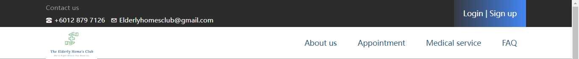

*Figure 6.1.6: Header without Login*

**

*Figure 6.1.7: Header with Login*

The header of our webpage is located at the top of the page which contains the Elderly Home’s Club logo and contact details via phone number and email address. A login/signup button is located at the top right corner of the header to enable more functionalities accessible by a registered member. The ‘login/signup’ button will direct the user to the login page. The login button will change to the user’s full name once they login into their account. Other than that, there are some features at the right bottom corner such as ‘about us’, ‘appointment’, ‘medical service’, and ‘FAQ’ which will direct the user to different pages that serve their purpose.

         For about us, it will direct the guest to a page showing detailed information about the Elderly’s Home Club. For an appointment, it will direct the guest to make an appointment for medical care. For medical service, it consists of 2 part which is ‘covid 19’ and ‘doctors’ to show the services that we provided for handling vaccination and covid test as well as displaying the personal information of doctors and their achievement in the medical care field. The header will be inserted in every page accessed by users and guests except for the user login page.

**Footer**

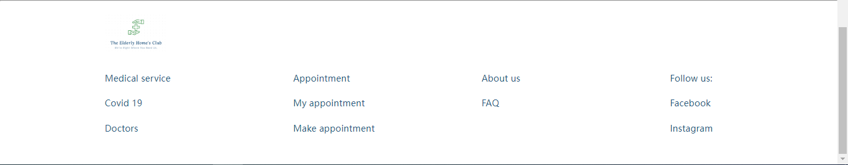

*Figure 6.1.8: Footer*

The footer of our webpage is located at the bottom of the page which contains quick and simply accessible to some other pages that are included in the entire webpage such as ‘medical service, ‘appointment’, ‘about us’, ‘FAQ’, and hyperlink to social media’. The footer will be inserted on every page accessed by users and guests except for the user login page.

**About Us**

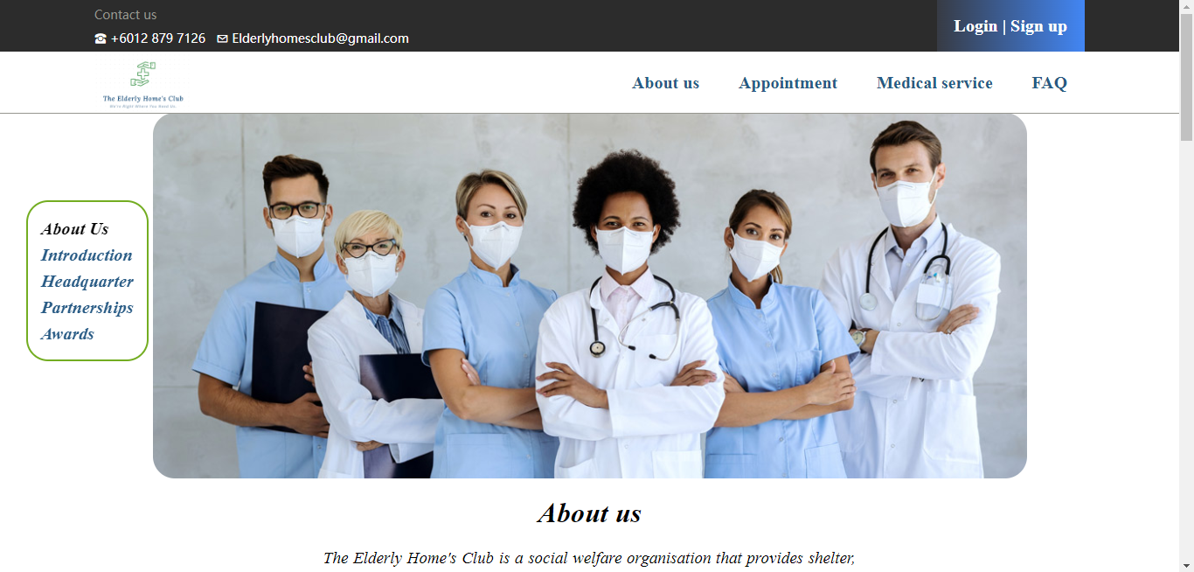

*Figure 6.1.9: About Us*

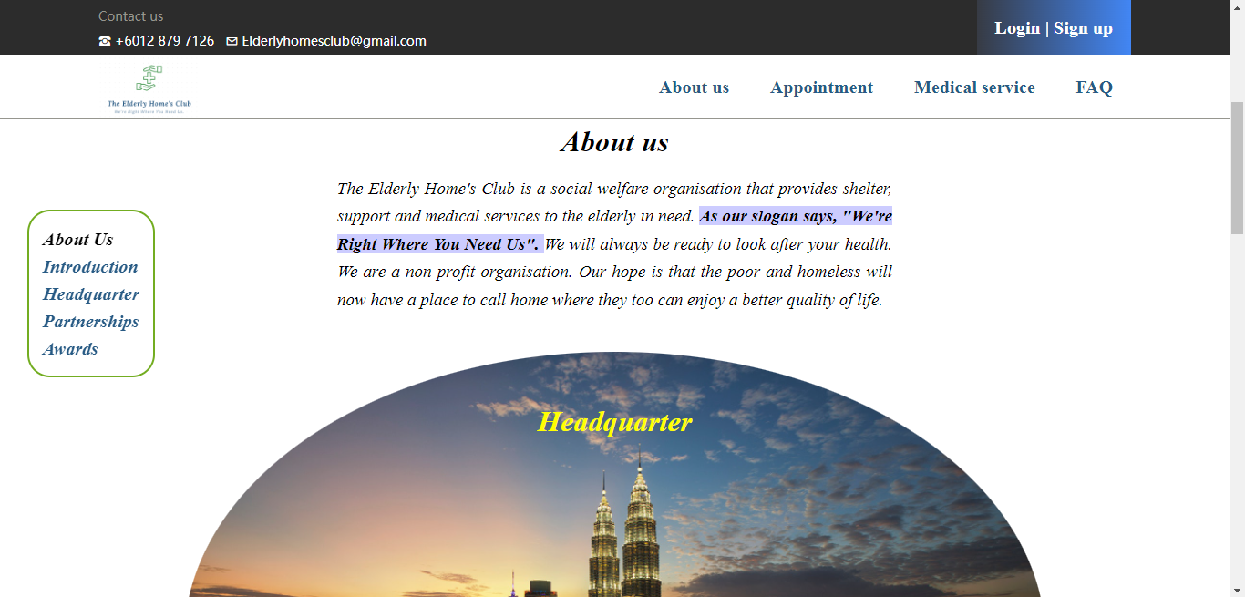

*Figure 6.1.10: About Us with Description*

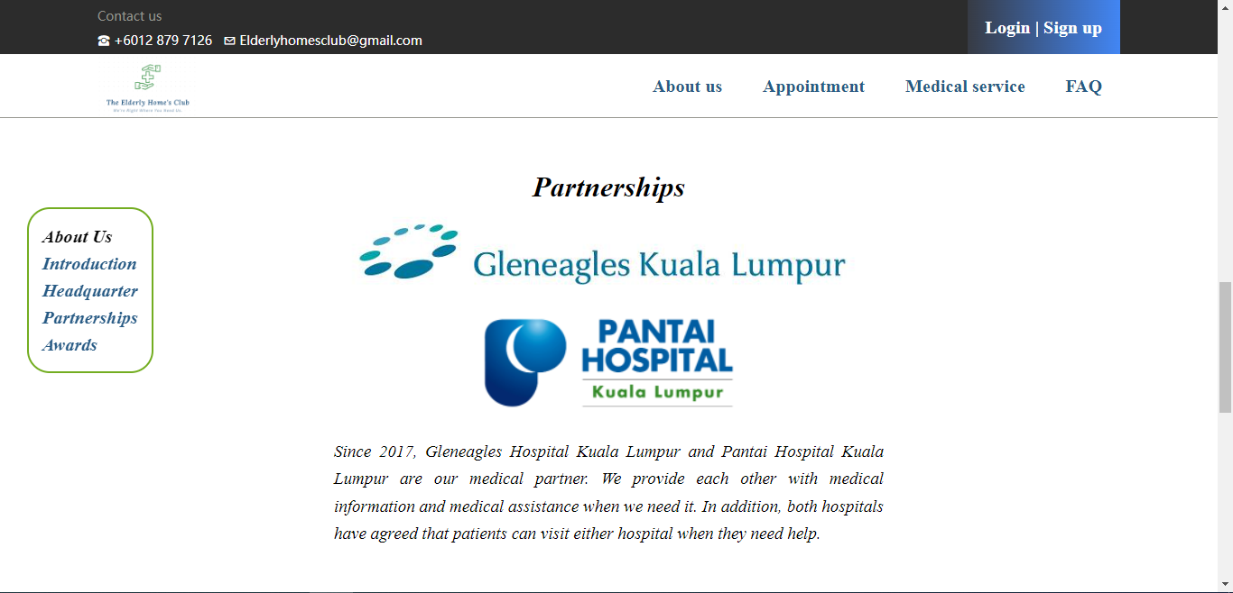

*Figure 6.1.11: About Us with Partnerships*

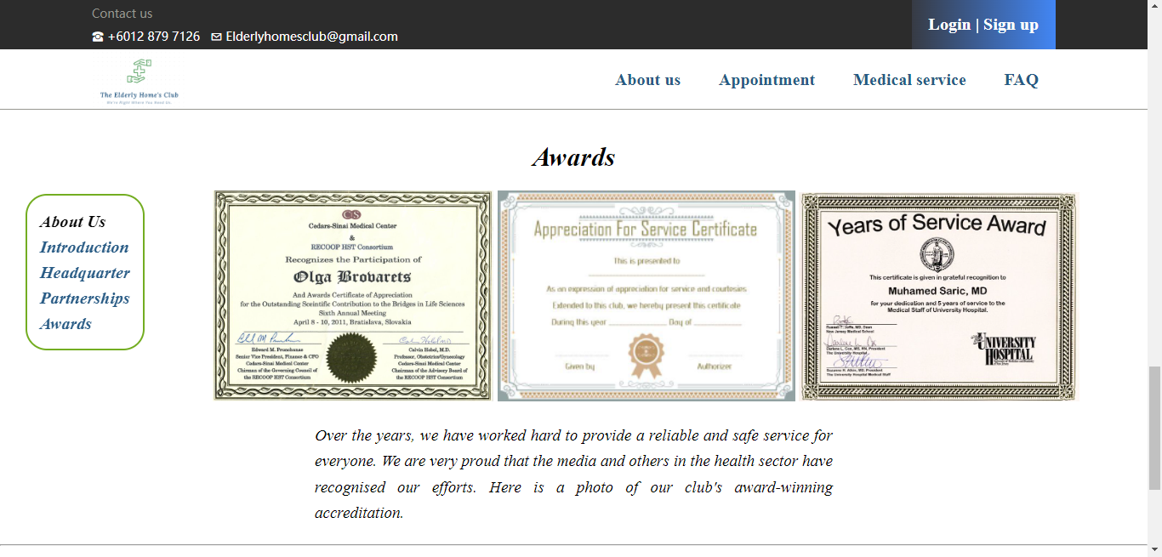

*Figure 6.1.12: About Us with Awards*

In the ‘about us’ part, the page contains 3 parts that show details about us, partnerships, and awards that have been collaborated and achieved by Elderly Home’s Club. The first part of ‘about us’ shows a detailed description of the Elderly Home’s Club to understand the mission and vision of the club as well as give a deeper insight into our operations. Furthermore, there are a lot of partnerships with other hospitals that are able to share and contribute their resources in terms of tools, doctors, and medicine to the community. For awards, the certificates awarded by the government and some other medical-related associations have a displayed on the last part of the page.

**Make an appointment**

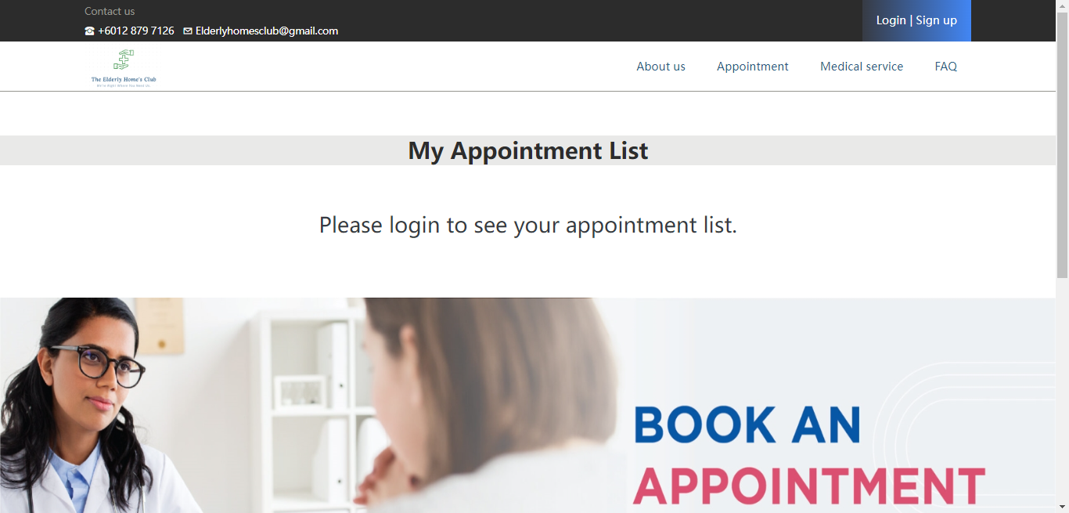

*Figure 6.1.14: My Appointment without Login*

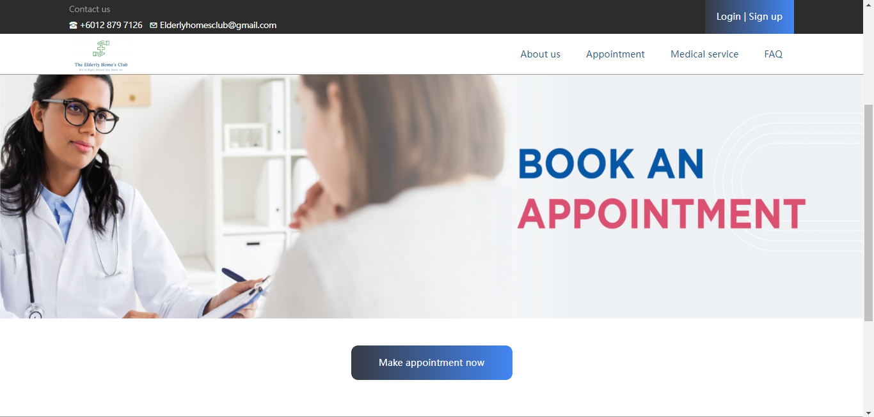

*Figure 6.1.15: My Appointment without Login 2*

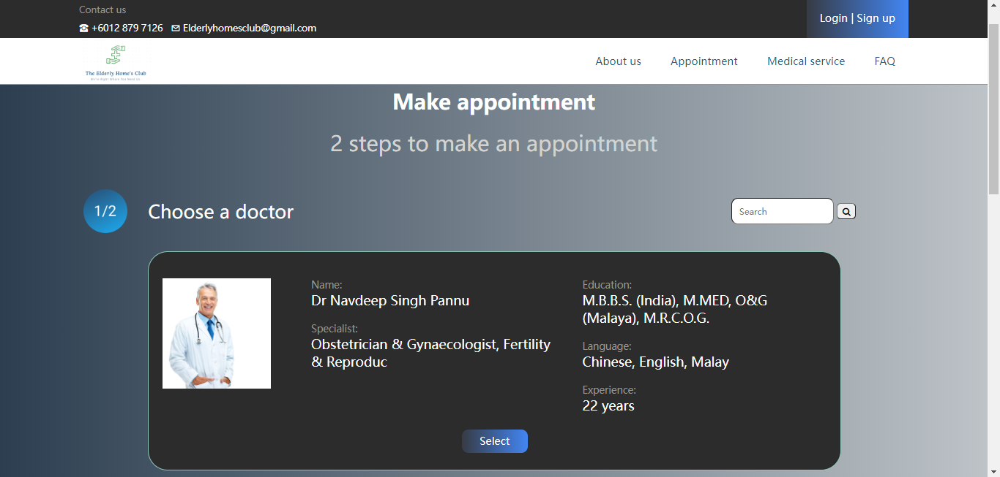

*Figure 6.1.16: Make Appointment without Login*

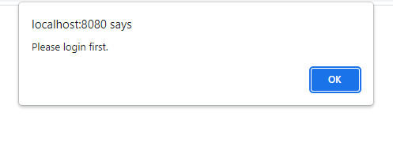

*Figure 6.1.17: Make Appointment without Login Alert Box*

The guest is able to access the appointment page to view the doctor's schedule. However, the guest without an account will not be able to reserve an appointment. Hence, an alert box will be popping out requesting the guest to log in to their account or register as a member of the Elderly Home’s Club.

**Covid 19**

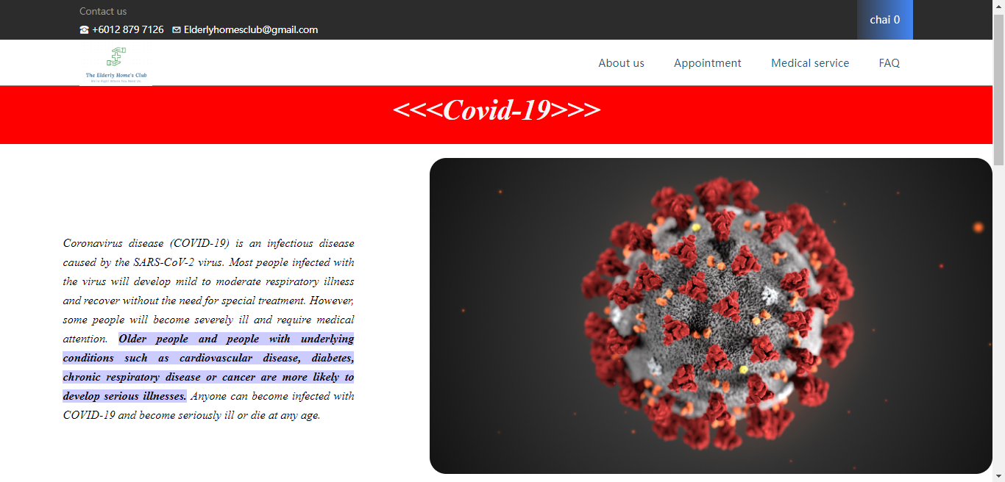

*Figure 6.1.18: Covid 19 Information*

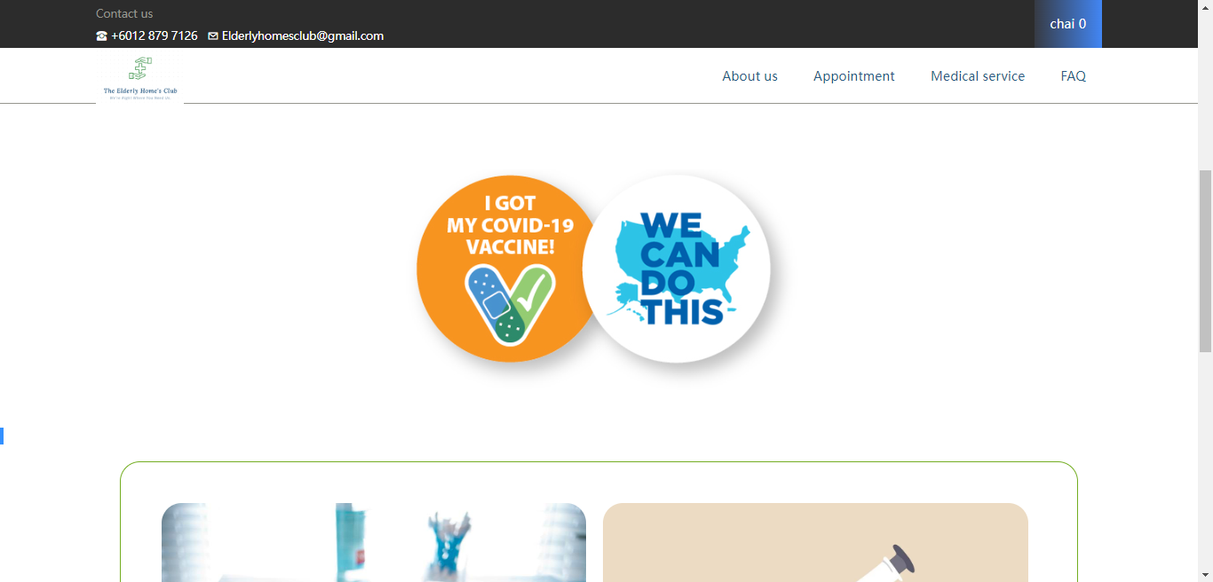

*Figure 6.1.19: Covid 19 Information 2*

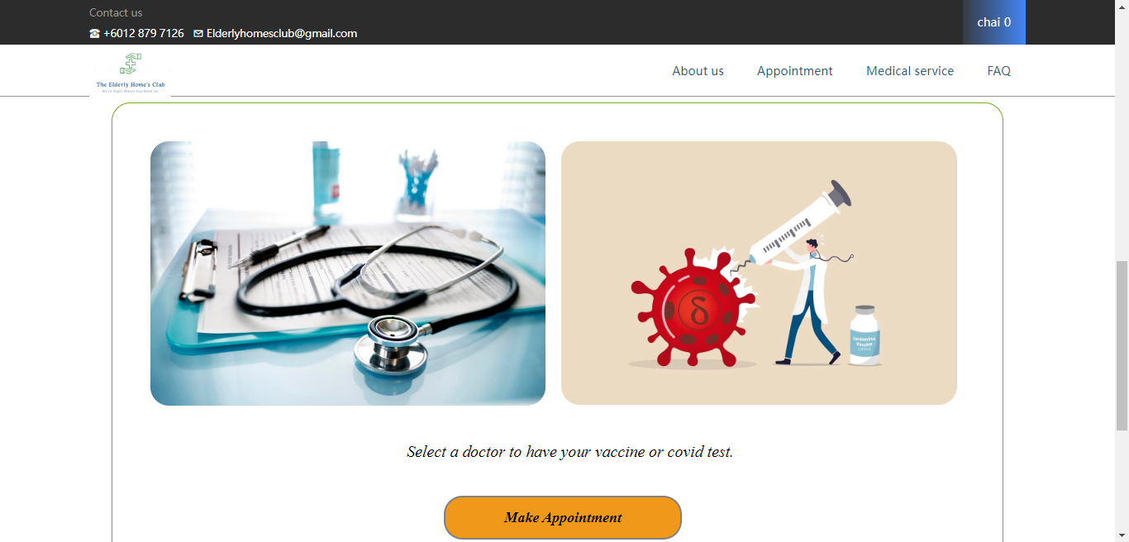

*Figure 6.1.20: Covid 19 Information 3*

The covid 19 page will display the services that we provide to deal with the covid 19 stage. We have set up a vaccination centre to conduct the covid tests as well as vaccine injections for elder citizens.

**Doctors**

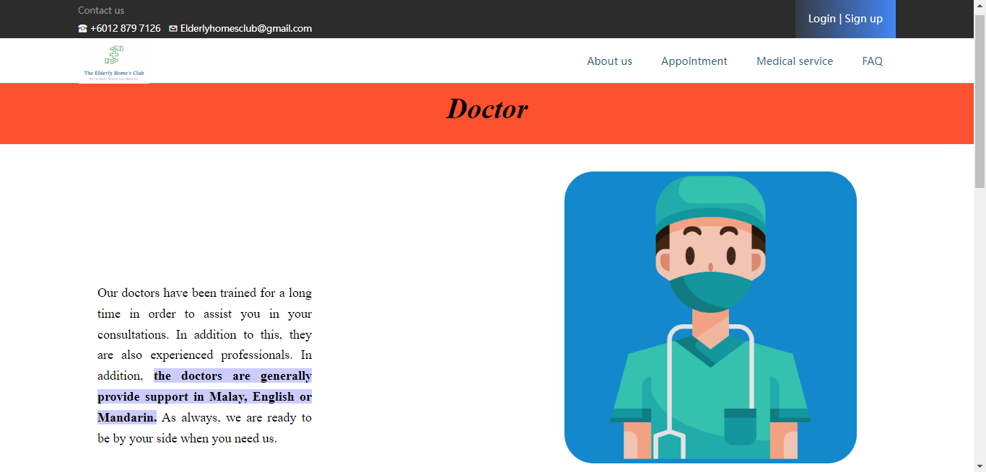

*Figure 6.1.21: Doctors Description*

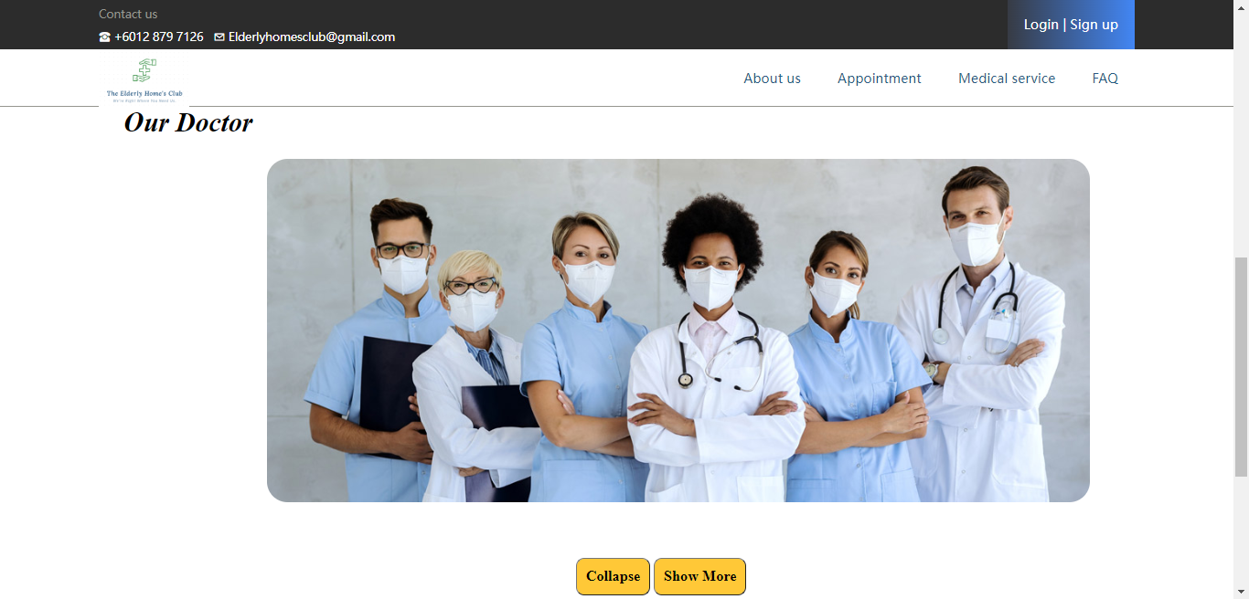

*Figure 6.1.22: Our Doctor*

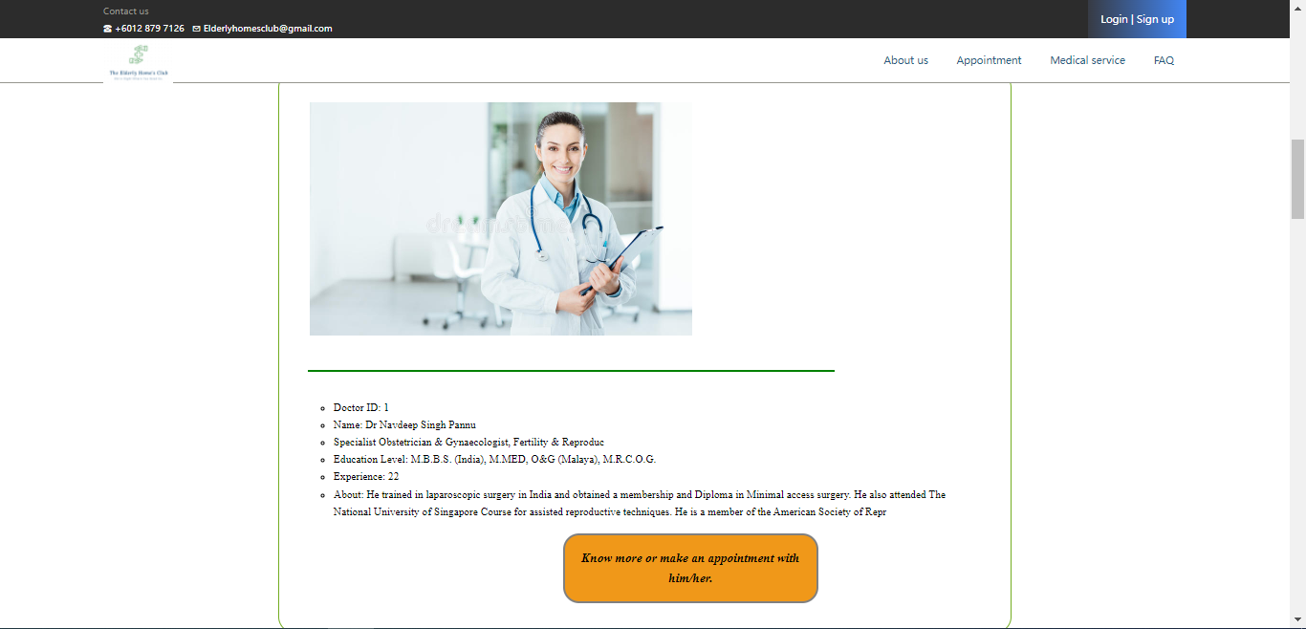

*Figure 6.1.23: Our Doctor Details*

For ‘our doctors’, the list of doctors and their detailed information will be displayed at its bottom after the guest click on ‘show more’ button.

**FAQ**

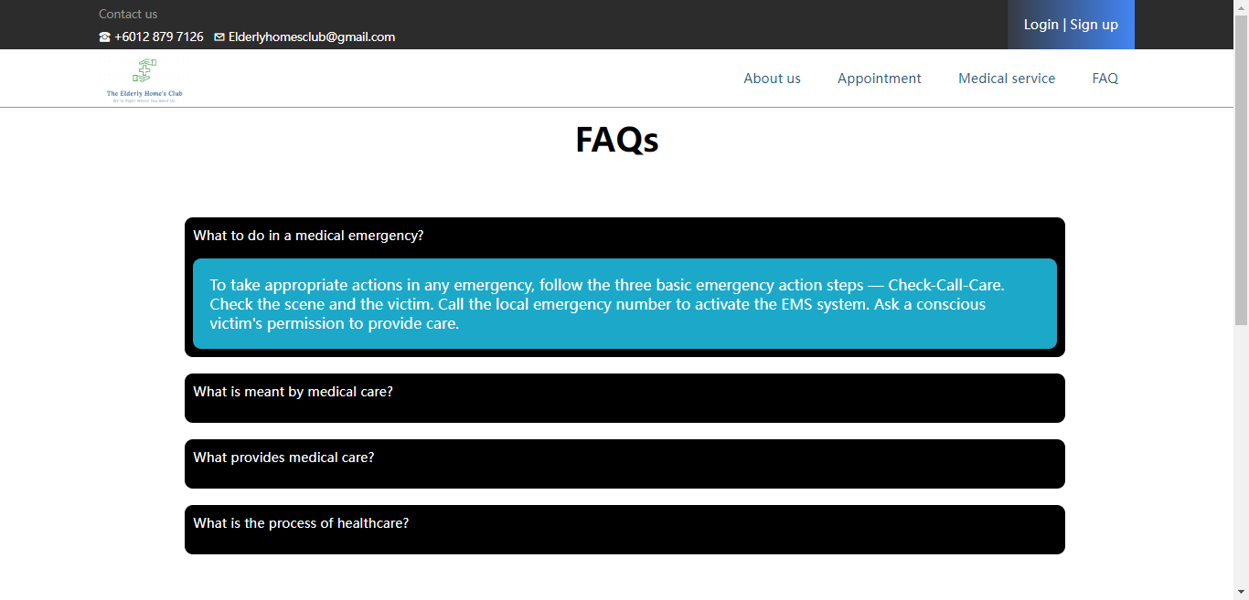

*Figure 6.1.24: FAQ*

For FAQ, the frequent ask questions will be displayed with the answer to assist them with a technical issue.

**Login**

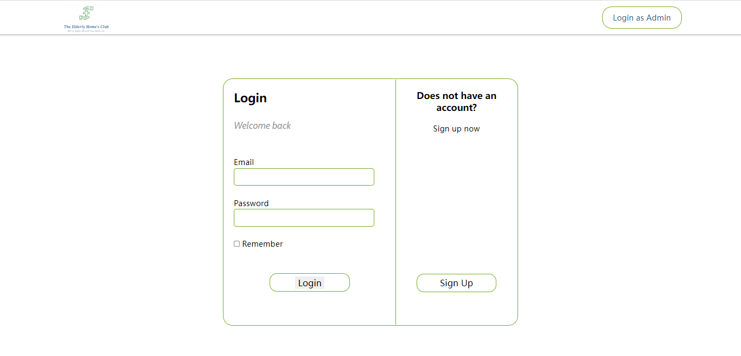

*Figure 6.1.25: User Login*

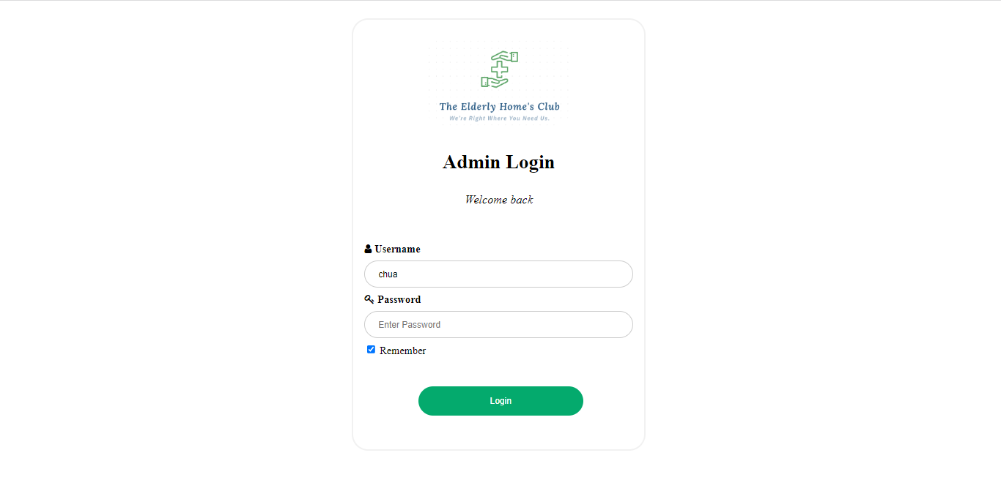

*Figure 6.1.26: Admin Login*

The user login page enables the existing member to log in to their account by using email and password. If the guest does not have an account, they can click on the sign-up button to register an account. The admin can log in themselves as an admin by clicking the top right corner button. The admin login page enables the admin to log in to their account by using a username and password.

**Register**

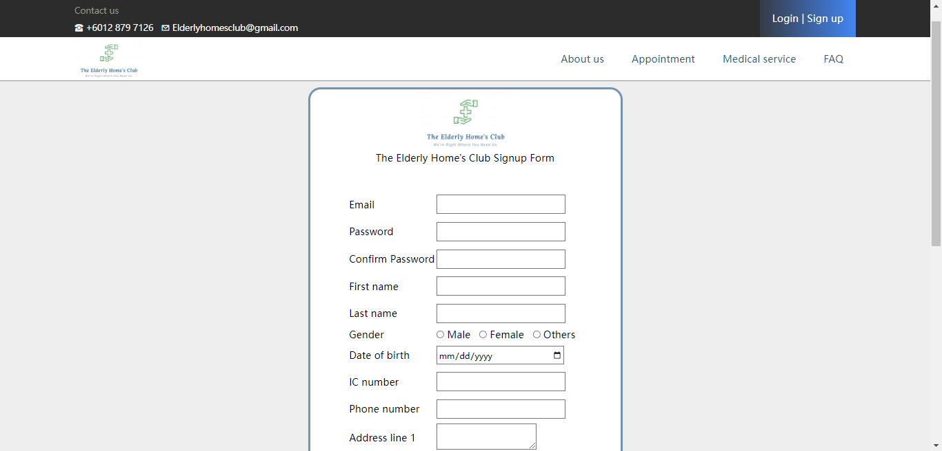

*Figure 6.1.27: Register an Account*

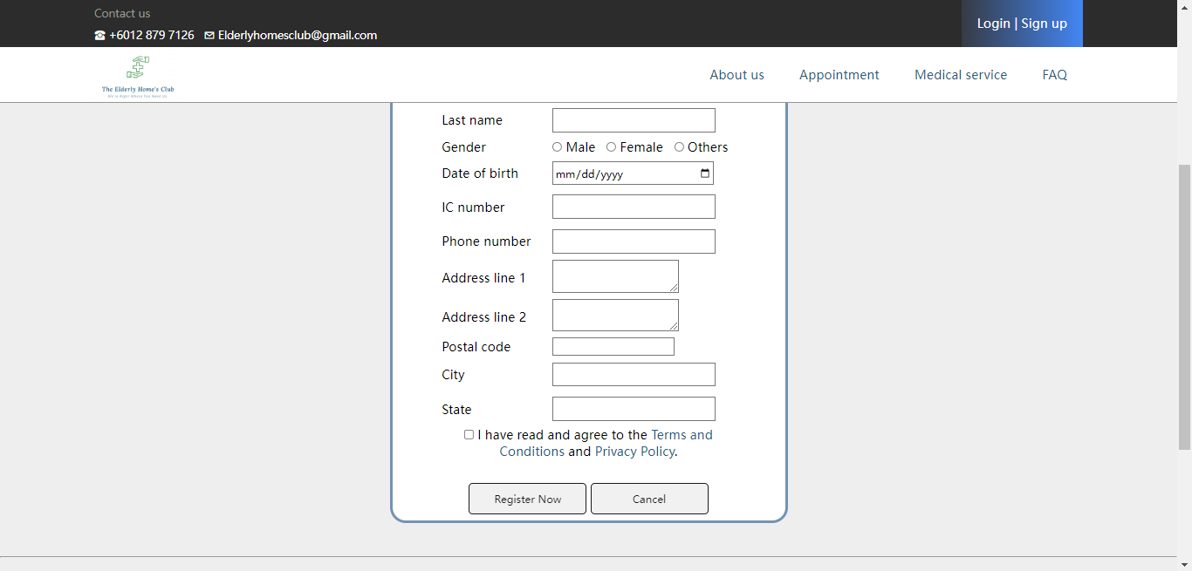

*Figure 6.2.28: Register an Account 2*

To register as a member, the guest will need to enter his personal information to create an account and record it into the system.

## User Functionalities

**User profile**

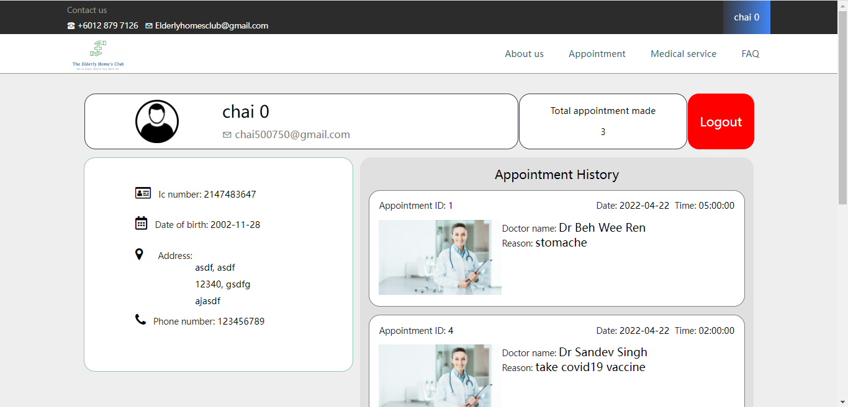

*Figure 6.2.1: User Profile*

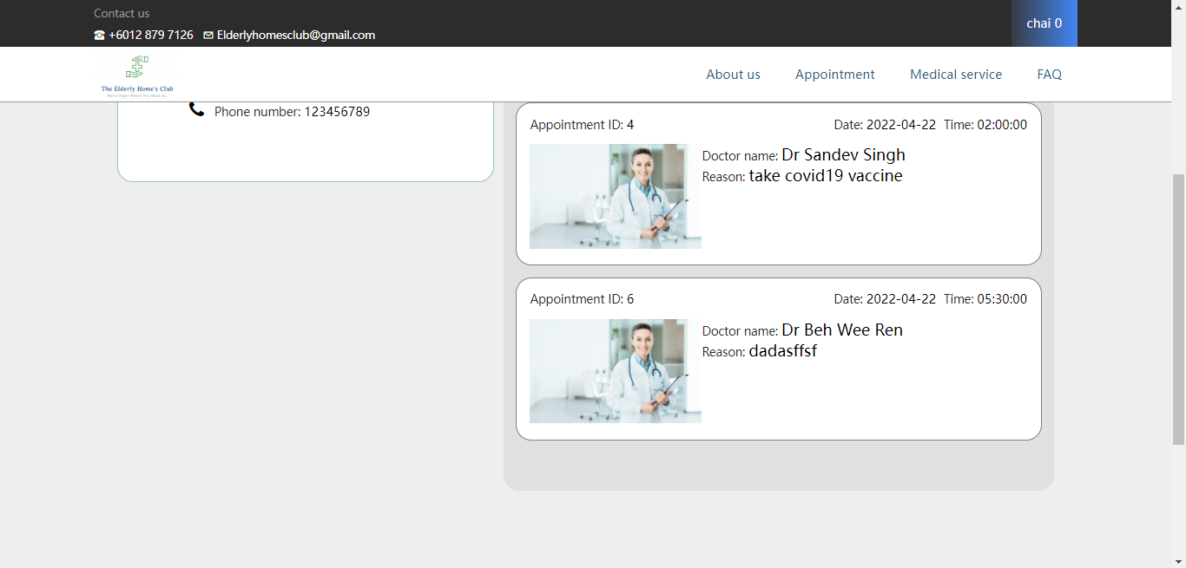

*Figure 6.2.2: User Profile 2*

In the user profile, it will contain all the personal information of the user such as name, email address, IC number, date of birth, address, and phone number. Other than that, a total of appointments reserved will be shown inside with the detailed appointment history. There is a logout button at the right corner to enable the user to log out of the account.

**Make An Appointment**

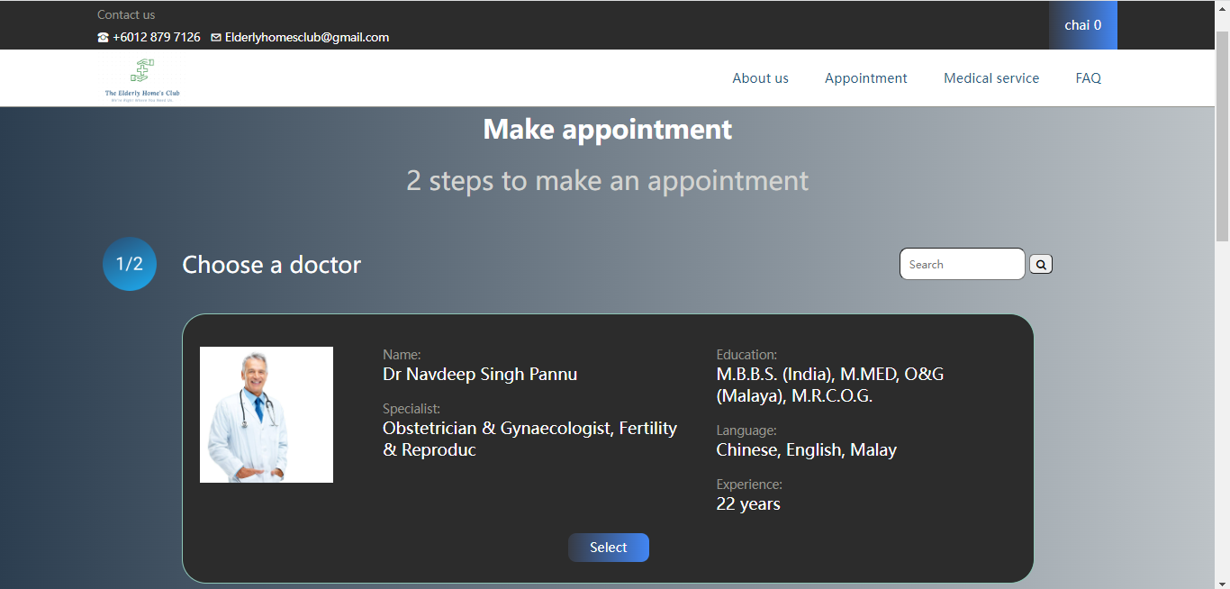

*Figure 6.2.3: Make an Appointment*

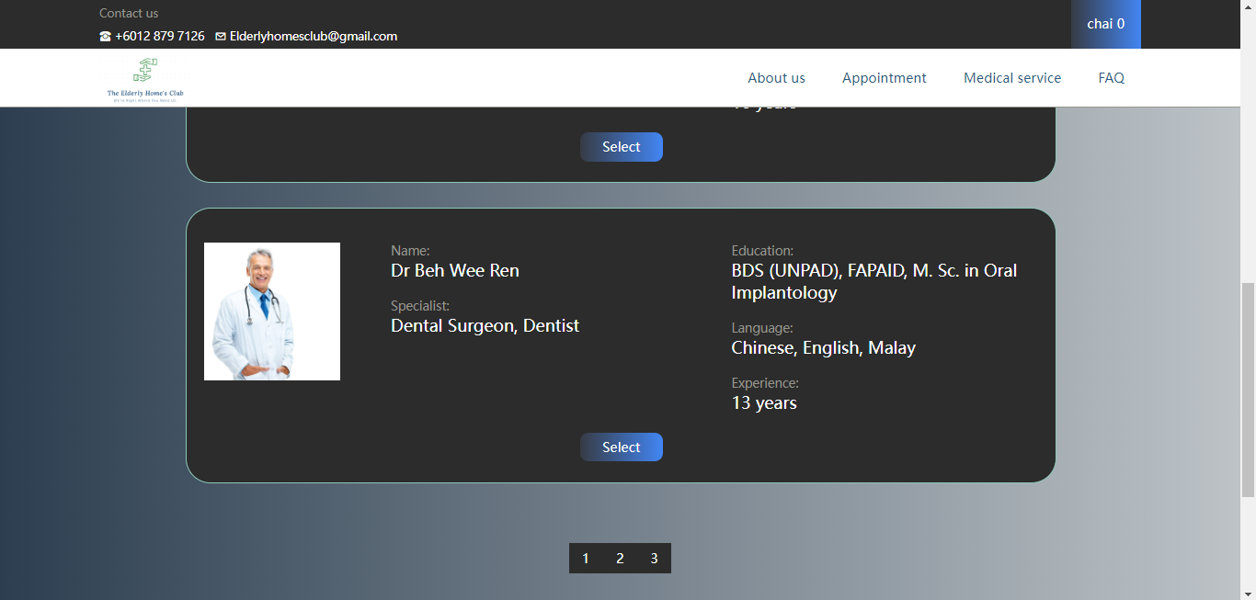

*Figure 6.2.4: Make an Appointment with Select Doctor*

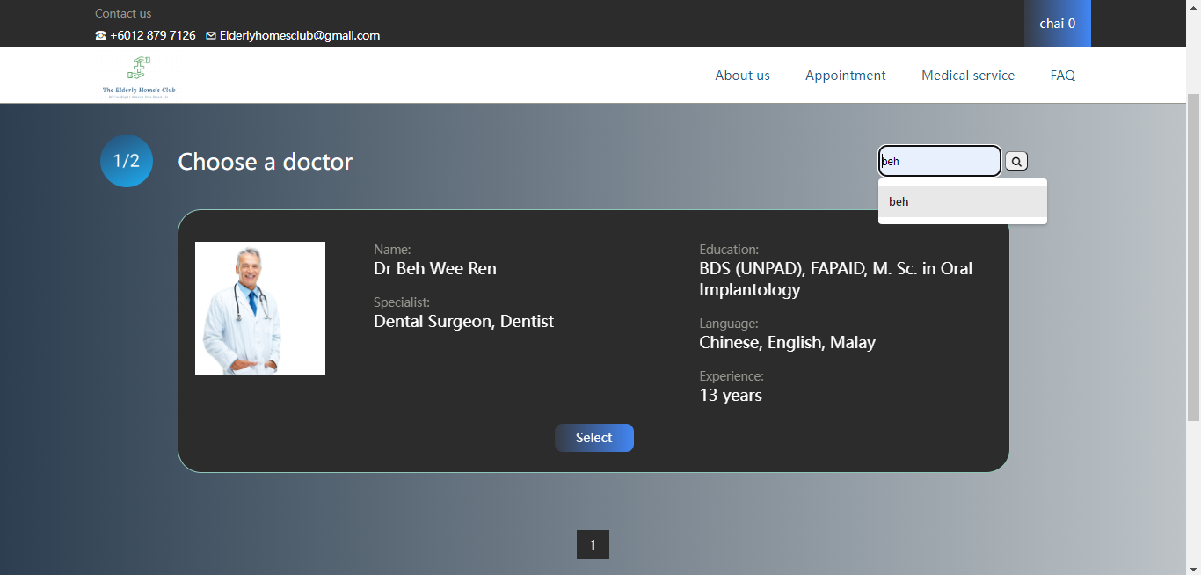

*Figure 6.2.5: Make an Appointment with Search Doctor*

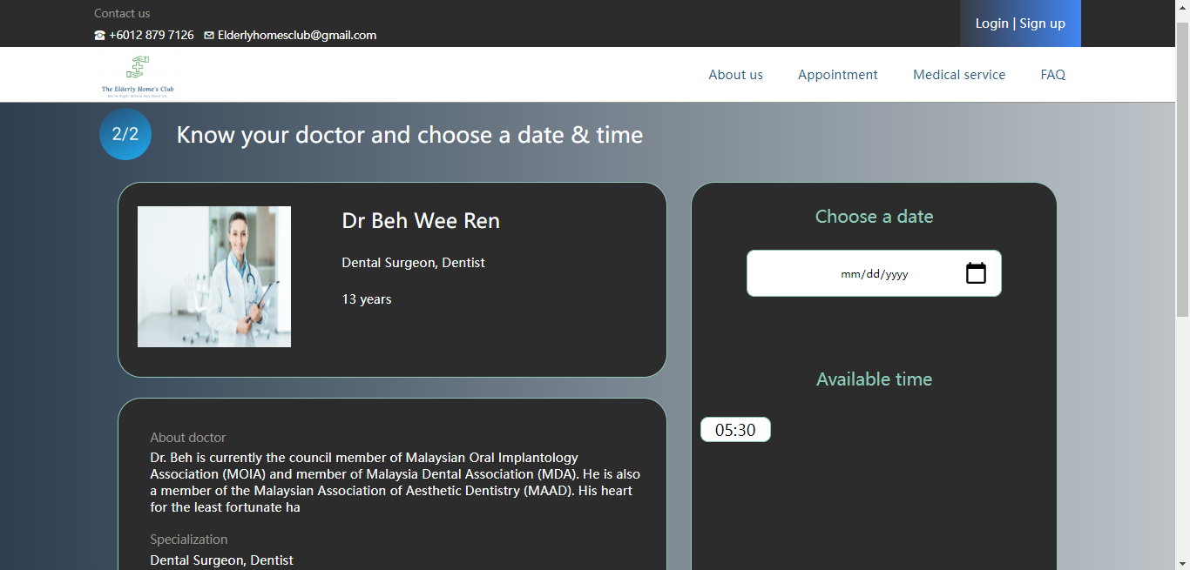

*Figure 6.2.6: Select doctor with Descriptions*

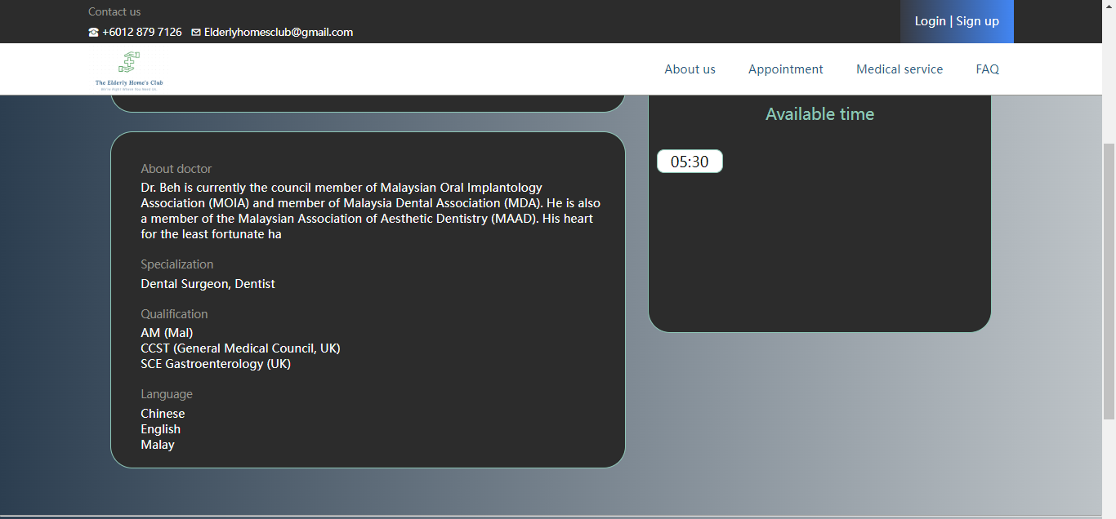

*Figure 6.2.7: Select doctor with Date and Time*

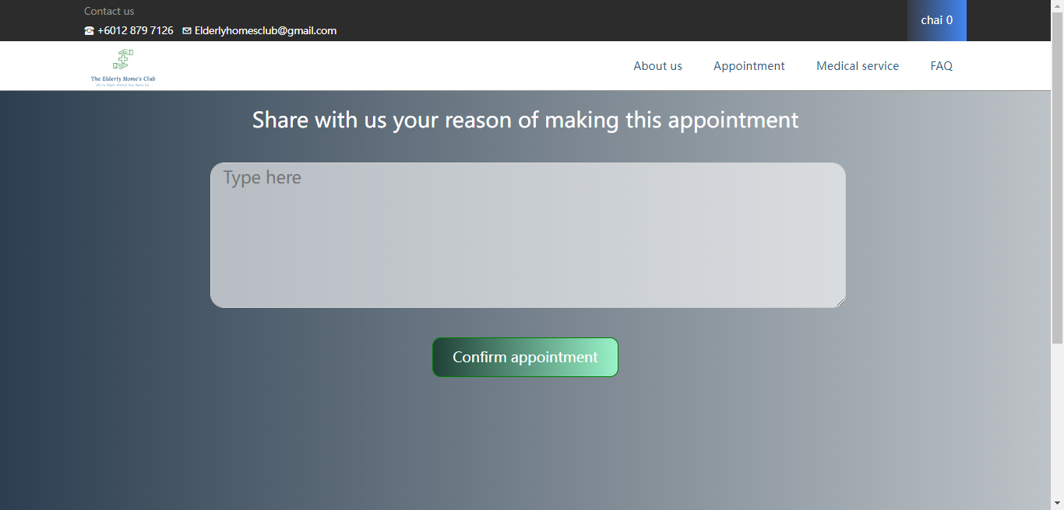

*Figure 6.2.8: Confirm Make Appointment*

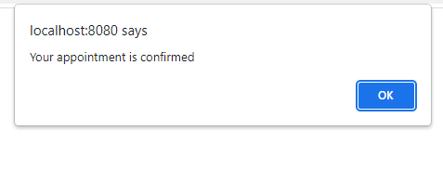

*Figure 6.2.9: Appointment Confirmed*

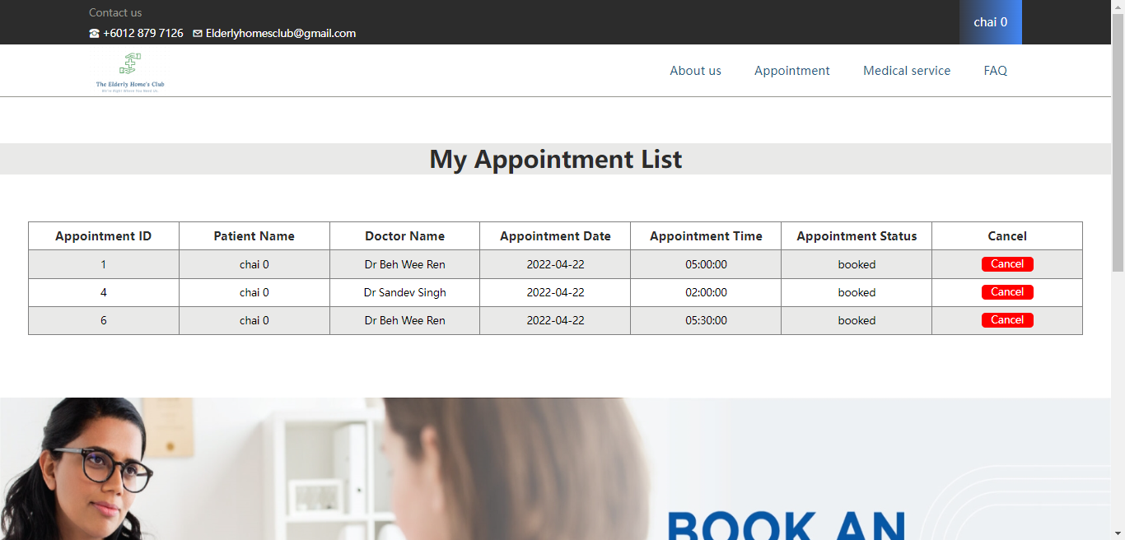

*Figure 6.2.10: My Appointment List*

It consists of 2 steps for the user to make an appointment. Firstly, the user has to choose a doctor listed down on the page or they can search for the targeted doctor by typing their name in the search box. Considered the name of the doctor will not be fully remembered, therefore the user will just need to search for the specific doctor’s name by entering a slightly similar alphabet or word into the search bar. After selecting a doctor, the user can simply view the details of the doctor as well as their available appointment schedule. The user can click on the appointment schedule which matches their expectation.

Once the date and time are selected, the user will need to describe his problem faced and the medical care required for the services. It ensures that the doctor can have well-prepared on the tools and medicines required for the appointment. Next, an alert box will be shown after the appointment is made and recorded in the database. The data will then be shown in a list of tables under my appointment list.

## Admin Functionalities

**Doctors**

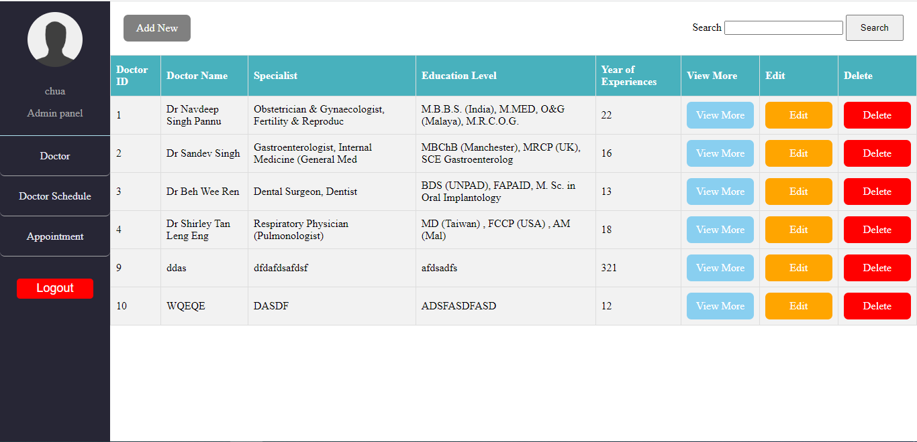

*Figure 6.3.1: Doctors List*

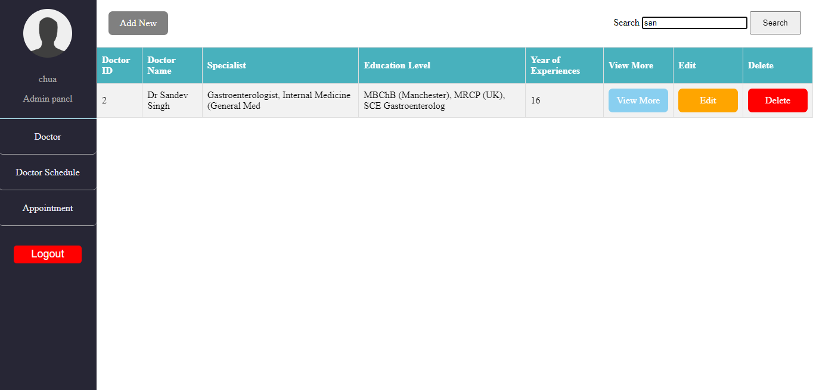

*Figure 6.3.2: Search Doctor List*

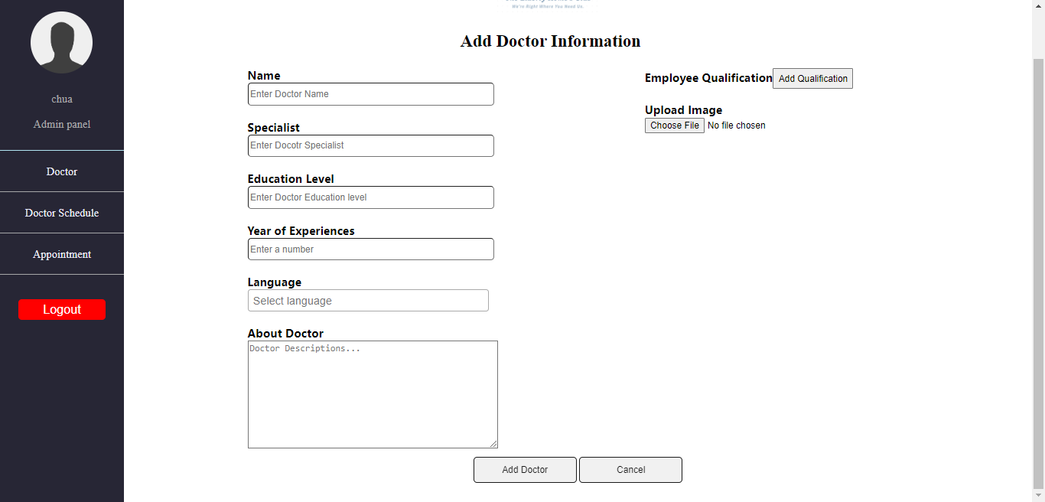

*Figure 6.3.3: Add Doctor Information*

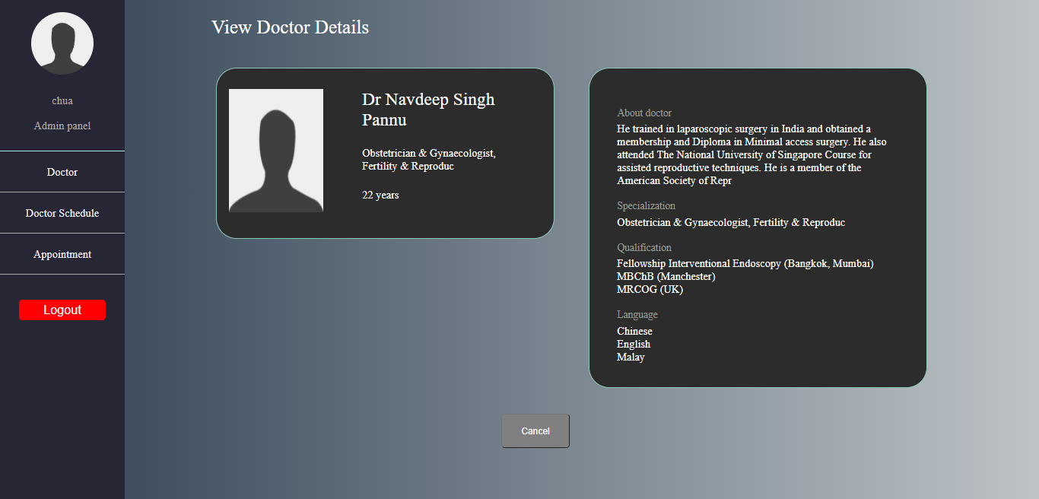

*Figure 6.3.4: View Doctor Details*

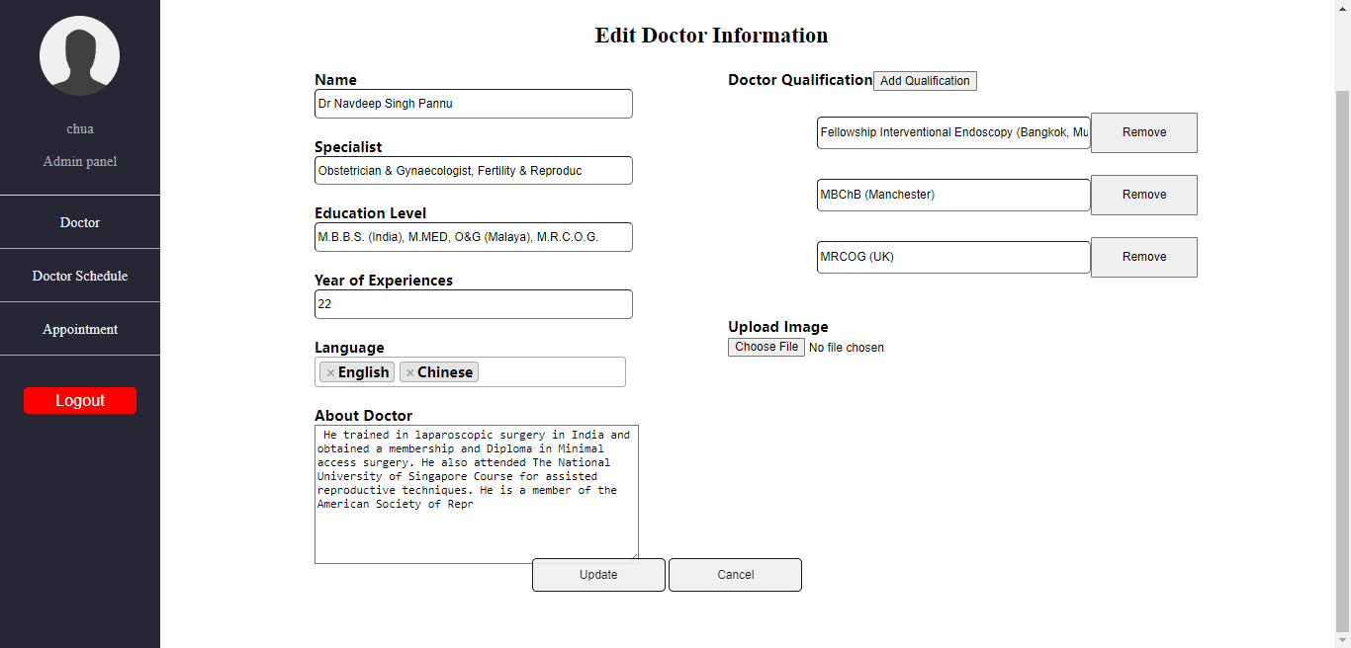

*Figure 6.3.5: Edit New Doctor Information*

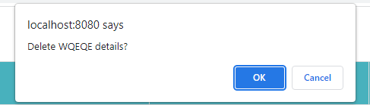

*Figure 6.3.6: Delete Doctor Information*

After the admin login to the webpage, the doctor list will be displayed to the admin. There is an admin panel on the left side of the interface. In the admin panel, there is a name of the admin, and three options which are ‘doctor’, ‘doctor schedule’, and ‘appointment’ can be selected by the admin. A red logout button is for the admin to log out of their account after they have done amending it.

In the doctor list, the admin is able to view the list of doctors with their brief information or search the doctor’s name by entering the alphabet or words similar to his name. The first action that can be done on the ‘doctor list’ page is to create new doctors who are willing to contribute to the community. Other than that, the admin is able to view the detailed information of the doctor by clicking the view more button. Furthermore, the admin can amend or update the information of the doctor to improve their reputation or avoid misunderstanding. Lastly, the admin can delete unwanted data of the doctor who do not serve in the Elderly Home’s Club anymore.

**Doctors Schedule**

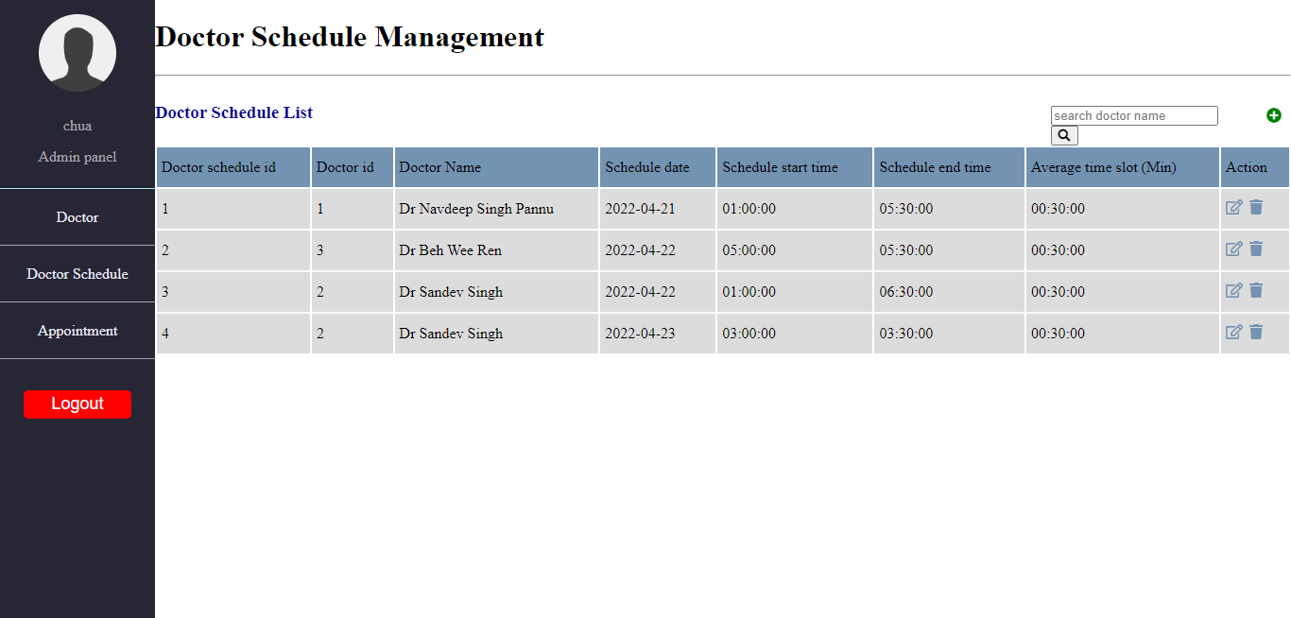

*Figure 6.3.7: Doctor Schedule List*

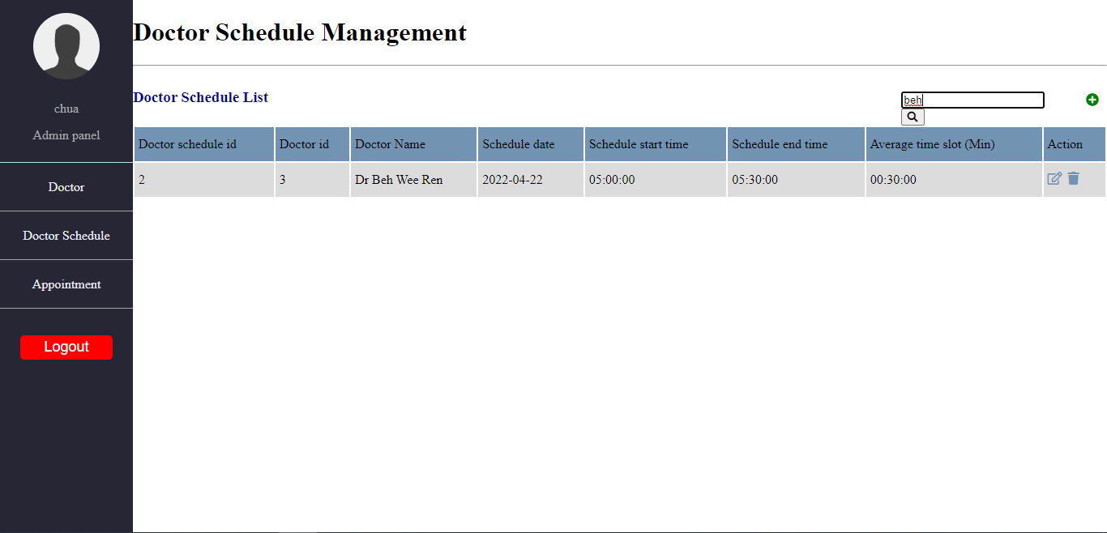

*Figure 6.3.8: Search Doctor Schedule*

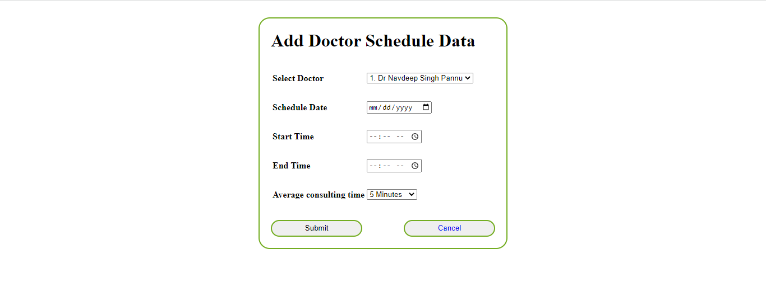

*Figure 6.3.9: Add Doctor Schedule Information*

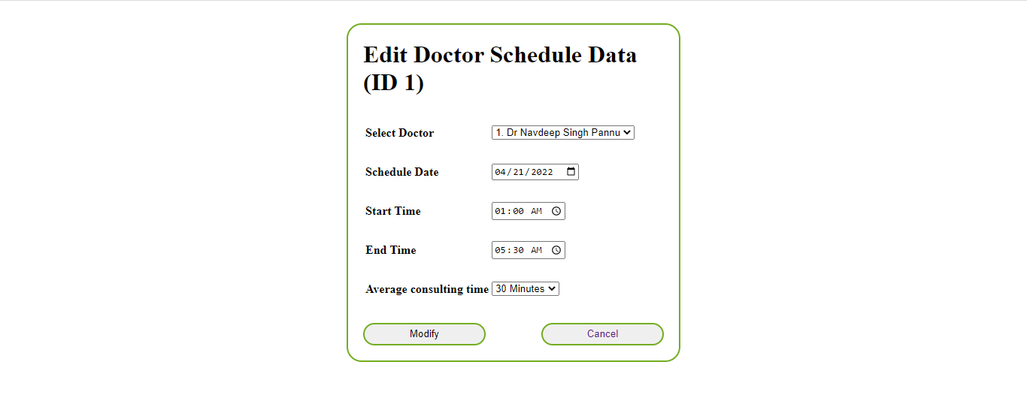

*Figure 6.3.10: Edit Doctor Schedule Information*

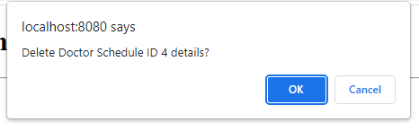

*Figure 6.3.11: Delete Doctor Schedule Information*

There is a list of doctor schedules displayed in the schedule option. The admin can search the reserved doctor schedule by entering the doctor’s name at the search bar, by doing so all the appointment schedules that are related to the doctor will be listed. There are three main actions that can be done on the doctor schedule page which are creating new, editing, and deleting the doctor schedule. The create new doctor schedule will direct the admin to the add new doctor schedule page, as well as the edit doctor schedule, which will direct the admin to the edit doctor schedule page.

There is a ‘plus’ logo beside the ‘search bar’ which is used to create a new doctor appointment schedule to reserve by the community. Furthermore, the admin can amend or update the specific doctor appointment schedule. Other than that, the admin can delete any unwanted doctor schedules that are not been reserved from the list to avoid misunderstanding.

**Appointment**

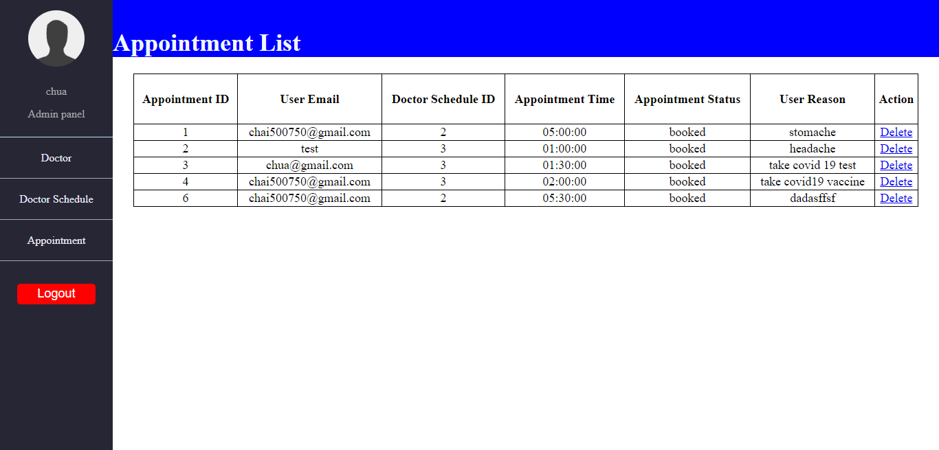

*Figure 6.3.12: Appointment List*

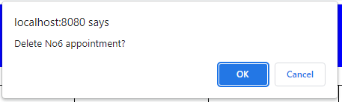

*Figure 6.3.13: Delete Appointment List*

For appointments, the admin is able to view all the appointment lists that have been scheduled with the doctor. The admin can delete the appointment if the particular appointment has any problem reported.

# References

w3schools. (n.d.). *PHP file_get_contents() Function*. Retrieved from w3schools: https://www.w3schools.com/php/func_filesystem_file_get_contents.asp